Expert Workshop
Restoration and Adaptation of Mountain Forests in Central and Northeast Asia

Bishkek, Kyrgyz Republic
October 19-22, 2015

Monday, October 19, 2015
Bishkek, City Hotel, 34 Baitik Baatyr street

Welcome Reception

Tuesday, October 20, 2015
Bishkek, City Hotel, 34 Baitik Baatyr street

Moderator
09:00-09:30 | Registration (Conference hall "Ala-Too")
09 : 30 – 09 : 35 | Opening
09:35-09:40 | The representative of the Government
09:40-09:45 | Welcome, President of National Academy of Sciences of the Kyrgyz Republic, Abdygany ERKEBAEV
09:45-09:50 | Welcome, Head of State Agency on Environment Protection and Forestry Under The Government of The Kyrgyz Republic, Sabyr ATADJANOV
09 : 50 – 09 : 55 | Welcome, National Academy of Sciences of the Kyrgyz Republic, Vice-President, Almaz ALDASHEV
09 : 55 – 10 : 00 | Welcome, National Academy of Sciences of the Kyrgyz Republic, Vice-President, Biimyrza TOKTORALIEV
10:00 – 10:20 | Welcome, IUFRO – John STANTURF (detail information about program)
10:20 – 11:00 | Photo, coffee-break
11:00-11:30 | Lessons Learned From The ASEAN Korea Environmental Cooperation Project—Prof. KANG Ho Sang, Seoul National University (video)
11:30-12:00 | Country Report - State Agency on Environment Protection and Forestry Under The Government of The Kyrgyz Republic
12:00 – 12:30 | Landscape management in mountainous areas: global commonalities, issues, and opportunities —Prof. Chadwick D. OLIVER, Yale University
12:30-13:00 | Contribution of FAO to the sustainable management of mountainous forests in the Kyrgyz Republic - Heino HERTEL
13:00-14:00 | LUNCH
14:00-14:30 | Forest and land use association of The Kyrgyzstan – BURHANOV Aitkul
14:30-15:00 | Agroforestry for climate change adaptation in Central Asia - Thevs Niels
15:00-15:30 | Some examples of recent international developments on forestry and mountains - BELEN Ismail, FAO, President of the Committee of Mediterranean Forestry Questions (Silva Mediterranean)
15:30-16:00 | Artificial regeneration of degraded broadleaf forests — Emile GARDINER, Center for Bottomland Hardwoods Research, U.S. Forest Service
16:00-16:30 | BREAK
16:30-17:00 | Foothills and low mountains of Uzbekistan: the state and prospects - BOTMAN Evgeniy, Uzbek Scientific Production Center for Agriculture
17:00-17:30 | Regeneration of Spruce Forests in Kyrgyzstan - CHYNGOZHOEV Nurstan, Forest research Institute of NAS KR
18 : 00 | Dinner at Hotel

Wednesday, October 21, 2015
Bishkek, City Hotel, 34 Baitik Baatyr street (Conference hall "Ala-Too")

09:00-09:30 | Growth and biomass allocation of one-year-old seedlings of scots pine (Pinus Sylvestris l.) under different photoperiod regimes from diverse seed sources of Mongolia - NYAM-OSOR Batkhuu, Department of Environmental Sciences and Chemical Engineering, National University of Mongolia
09:30-10:00 | Current status of the forests of Tajikistan and methods of their restoration - KHISAINOV Nurali, State enterprise of Research Institute on Forestry of State Agency of Forestry under Government of Republic of Tajikistan
10:00-10:30 | Monitoring of stem pests in Medeo Zailisky Alatau - MAZARZHANOVA Kuralay, S.Seifullin Kazakh Agro Technical University in Astana
10:30-11:00 | BREAK
11:00-11:30 | Turkey’s experiences on management of mountain forests –  BELEN Ismail, FAO, President of the Committee of Mediterranean Forestry Questions (Silva Mediterranean)
11:30-12:00 | The role and importance of natural regeneration in the formation of pine stands in clearings of Buryatia - ONUCHIN Aleksandr, Institute of Forest V.N. Sukachev Siberian Branch of Russian Academy of Sciences
12:00-12:30 | The experience of ecological and economic assessment of forests in Kyrgyzstan - RAZHAPBAEV Muslim, Forest research Institute of NAS KR
12:30 –13:00 | Experience reforestation (Frunze forestry) - ABYLGAZIEV Isabek, Frunze mechanized forestry
13:00-14:00 | LUNCH
14:00-14:30 | Restoration of juniper forests of the South Kyrgyzstan – SHAMSHIEV Bakytbek, Osh Technological University
14:30 –15:00 | Features of recovery of sea buckthorn in the south of Kyrgyzstan - KULIEV Arstanbek, Botanical Garden of the NAS KR
15:00-15:30 | IUFRO-TF forest adaptation and restoration under global change - a start of a global network
15:30-16:00 | Community forest of Nepal: how it maintains ecosystem services and help in rural climate change adaptation? - Bidur Khadka, Yokohama National University
16:00 –16:30 | BREAK
16:30 –17:00 | Experience of afforestation in rainfed foothills of Kyrgyz ridge. CHYNGOZHOEV Nurstan, Forest research Institute of NAS KR
17:00 – 17:30 | Restoration and Adaptation to Climate Change—John STANTURF, US Forest Service
18 : 00 | Dinner

Thursday, October 22, 2015

08 : 30 | Depart from Hotel
09 : 30 – 12 : 00 | Visit of Forest and land use association of Kyrgyzstan’s experimental plot.  Visit Frunze forestry (leshoz)
12 : 00 – 13 : 30 | Lunch Breack
13 : 30 – 15 : 00 | Visit the State National Natural Park “Ala-Archa”
15 : 00 – 15 : 30 | Dinner Break
 | Return to hotel

Location Map
From airport to hotel
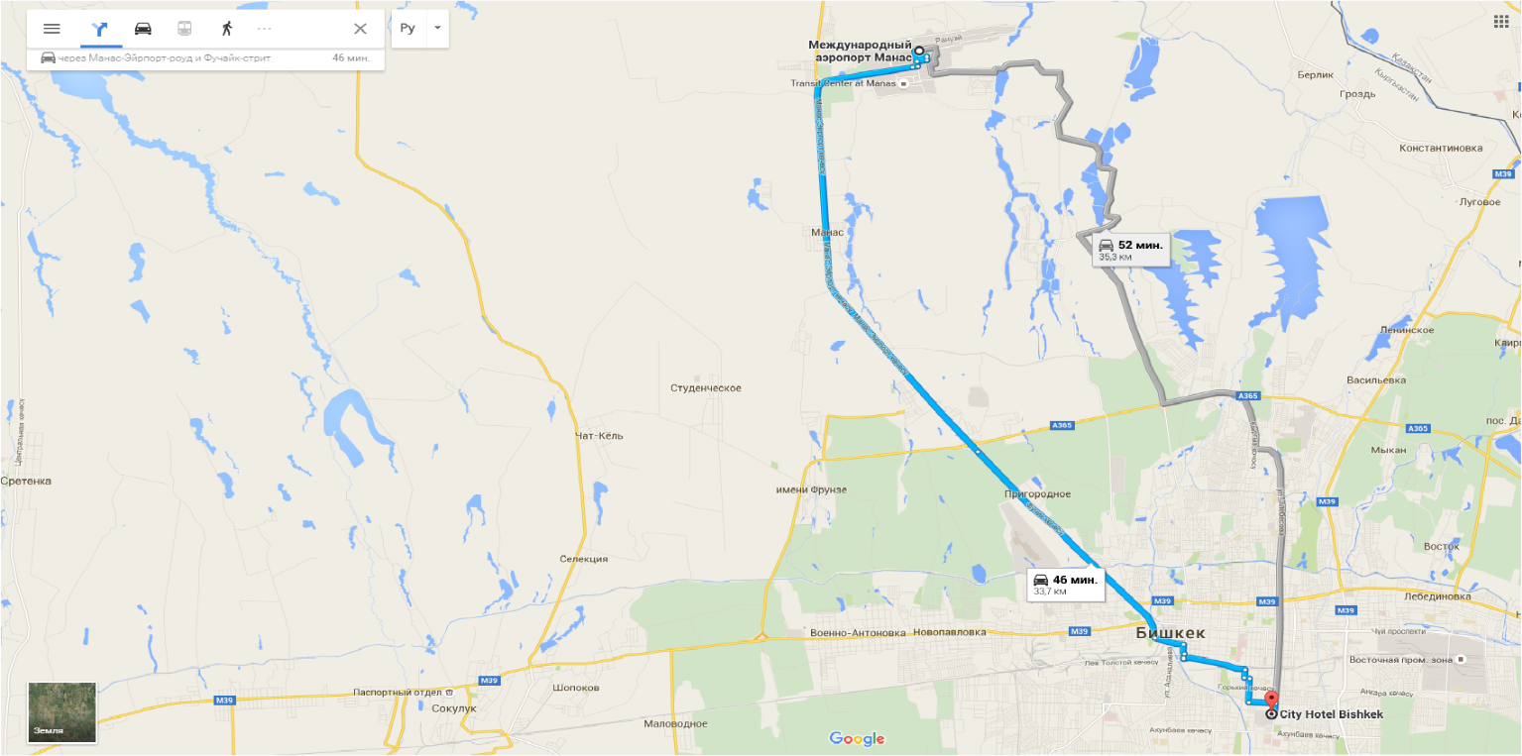
Hotel Address
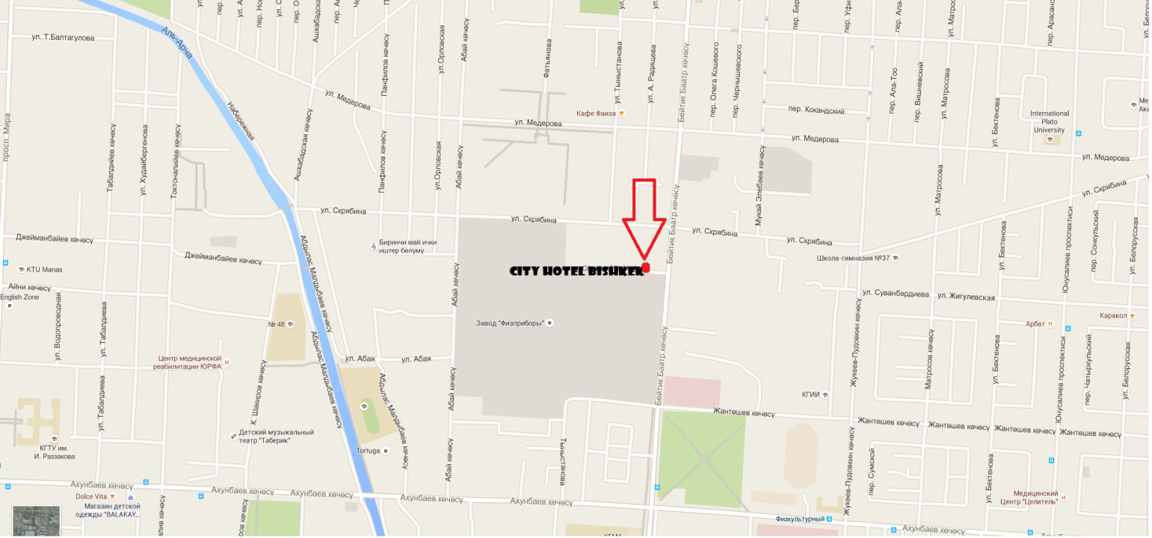
Hotel Address
City Hotel Bishkek
34 Baitik Baatyr street,
Bishkek, Kyrgyz Republic 720003
Tel.: +996 312 97 62 62,
e-mail: hotel@cityhotel.kg
http://www.cityhotel.kg/en/

