The Impacts of Climate Change on Forests and Sustainable Forest Management in Uzbekistan.
Authors: Abduvokhid Zakhadullaev¹, Dildora Aralova^{,2,3}, Abdusalom Normatov⁴, Masudkhon Ismoilov⁵
- State Committee on Forestry of the Republic of Uzbekistan, Uzbekistan. Deputy Director, Email: info@urmon.uz ; miyon2001uz@mail.ru
- Research Institute of Environment and Environmental Protection Technologies at the State Committee for Ecology and Environment Protection of the Republic of Uzbekistan, Uzbekistan. Email: aralovad@gmail.com
- Dresden Technology University, Dresden, Germany. Email: aralovad@daad-alumni.de
- Forestry Research Institute at the State Committee on Forestry of the Republic of Uzbekistan, Uzbekistan.
- Academy of Science of the Republic of Uzbekistan, Uzbekistan makhmudov.khusanboy@bk.ru.

Abstract. Uzbekistan is a country with the low forest cover (about 7% of country's land is covered with forests). However, forests play a significant role in the diverse of arid zone’s ecosystem. The environmental disaster in the Aral Sea region of the part Uzbekistan, formerly abundant in flora and fauna species, resulted in a sharp decrease in biological diversity in this area. The exposed seabed has turned into a desert, which at the present time is a source of tons of salty dust, blown away by the wind and carried along for thousands of kilometers. According to experts, the rate of warming in Uzbekistan is higher than the world average, and by 2030-2050, the air temperature in the region may rise by 1.5-3.0°C. However, the highest rate of temperature rise is expected to occur in the Aral Sea region.
In order to adapt to climate change and increase the effectiveness of the Republic of Uzbekistan in fulfilling its obligations under the Paris Agreement, as well as to ensure the achievement of national goals and objectives in the field of sustainable development until 2030 the forests and trees could provide up to 30% of greenhouse gas mitigation in Uzbekistan. Correspondingly, based on topography, soil and climatic conditions, the country’s forests (forest covered areas) are divided into mountain forests, floodplain valley forests, and desert forests. A new salt desert (Aralkum) with an area of 5.5 million hectares (Mha) appeared in Central Asia and national-scale attempts to restore dried Aral Sea Basin in Uzbekistan related to greening the land. Restore the desert forest or the Aral Sea region in Karakalpakstan is the initiative belongs to the President of Uzbekistan Shavkat Mirziyoyev and adopted on declaring the Aral Sea region a zone of environmental innovations and technologies. Currently, 1M500K ha lands has planted desert forest type tree and drought-resistant saxaul as Haloxylon aphyllum and Tamarix ramissossima. The main ecological task of forests and woodlands in the area of Aral Sea basin related to greening area, affecting climate change mitigation, remains carbon sequestration, retention of sand and dust, and regulation of water balance. The forest lands in Uzbekistan amounted to 1.37 million ha (3% of the total territory) in 2000 but they have reached 3.33 million ha (7.3% of the territory) by 2013. While the forest plantings were increased in 4 times upcoming years (2018-2020) under Uzbek and Kazakh Government’s initiative, especially in Karakalpakstan region in the dried bottom of the Aral Sea Basin. Generally, the average annual temperature rise observed at most stations in Uzbekistan since 1950 was statistically significant, and the heating trend was almost twice as high as the natural variability. The highest warming rates are recorded in the north of the country (Karakalpakstan) and in large cities (0.30-0.43 ° C for 10 years), the lowest in mountainous areas (0.10-0.14 ° C for 10 years).

Projected change in the mean near-surface air temperature in degrees relative to the period 1986-2005 as simulated by MPI-ESM.
Future scenarios for Central Asia colors ranging from yellow to red indicate a warming - the more intense the color, the stronger the projected warming.
Any of the scenarios RCP2.6 (2 degree target), RCP4.5 (2 degree target)
or RCP8.5 (5 degree target) shows in the selected using the scenario.
simultaneously displays the mean change in temperature for the three extreme scenarios RCP2.6 and RCP8.5 or for all three scenarios at the same time.
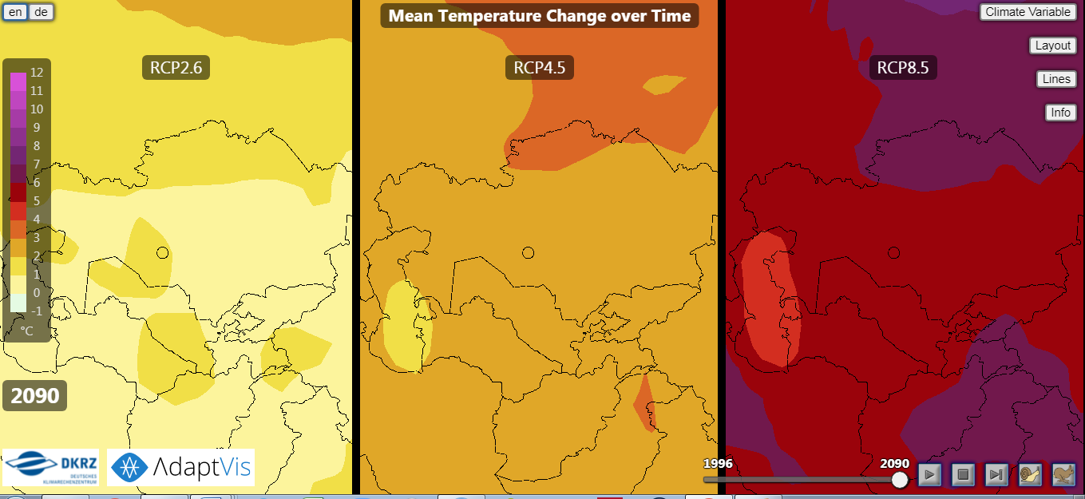
Adapted from https://www.dkrz.de/webvis/
Mean annual cycle of the projected change in precipitation in percent for the period 2071-2100 relative to 1986-2005 as simulated by MPI-ESM. Colors ranging from yellow to red indicate a decrease, blue colors an increase in precipitation. The more intense the color, the stronger the projected increase or decrease. All three scenarios (RCP2.6, RCP4.5 and RCP8.5 can be displayed side-by-side.
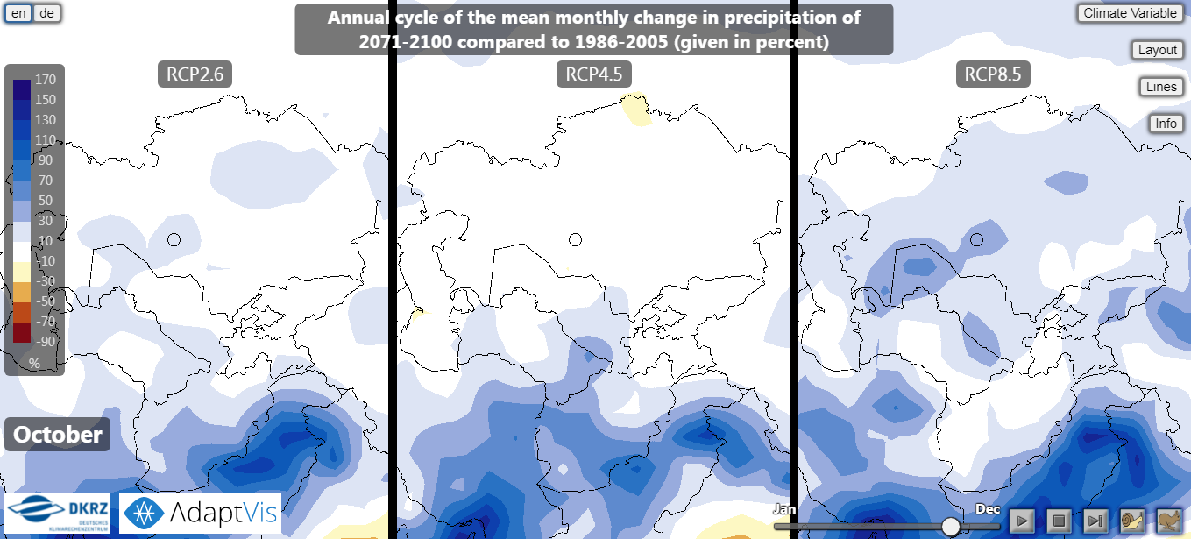
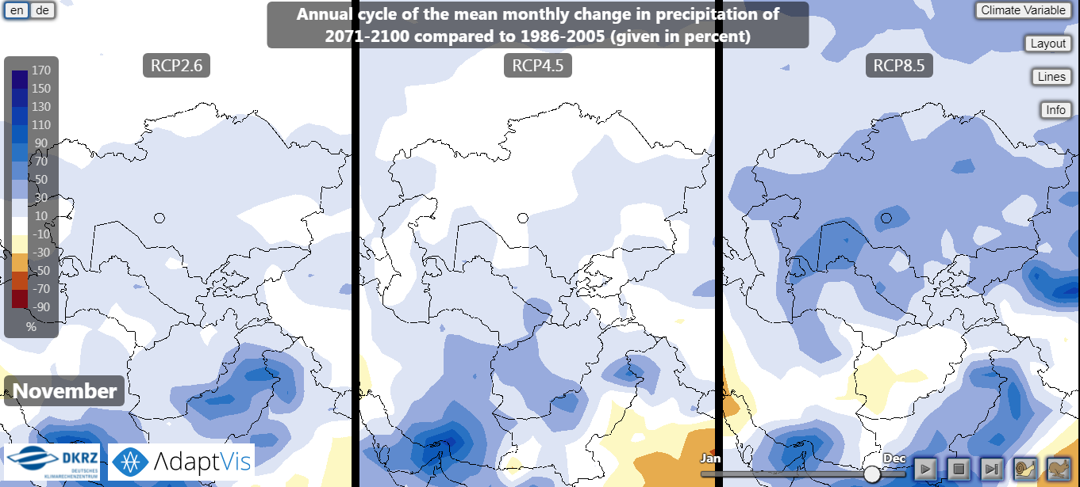
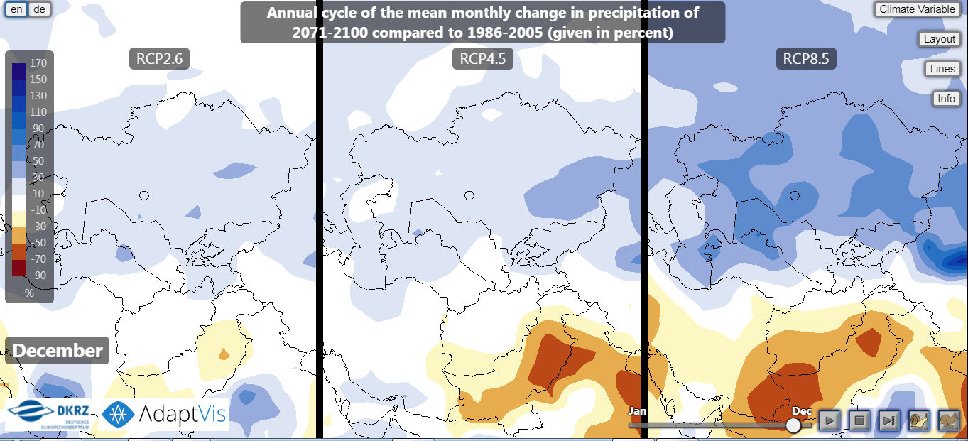
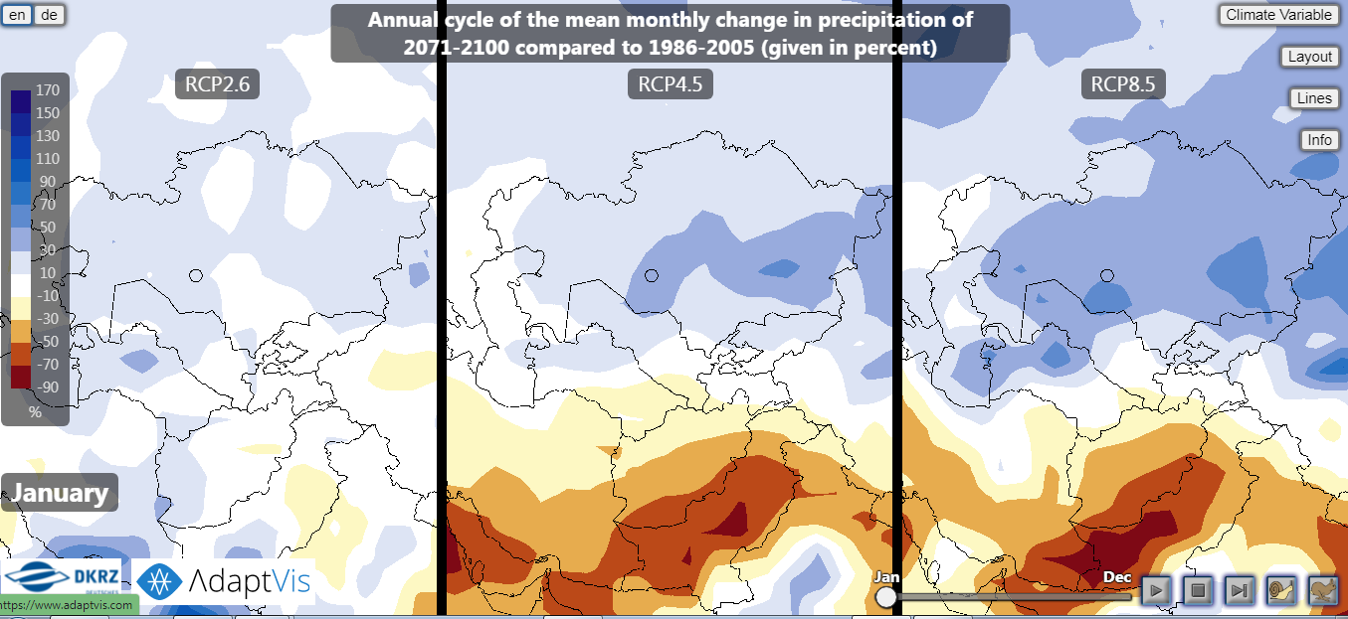
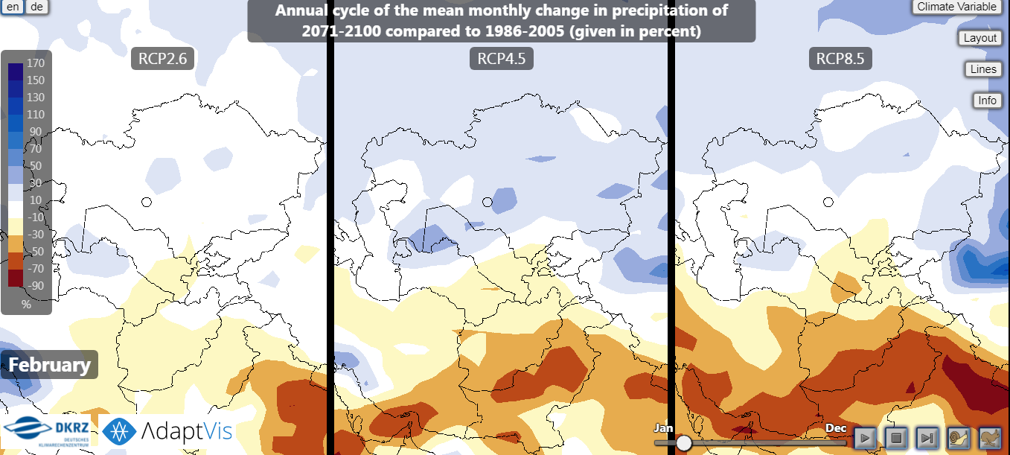
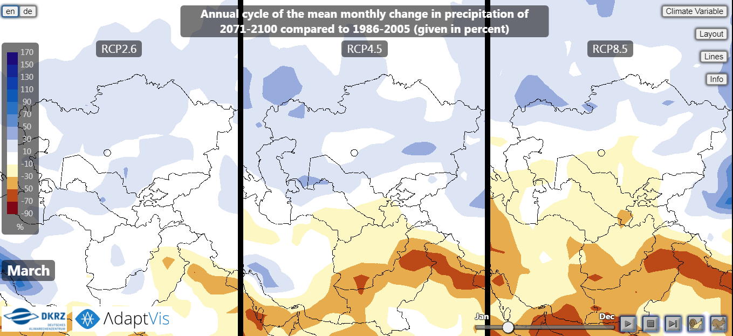
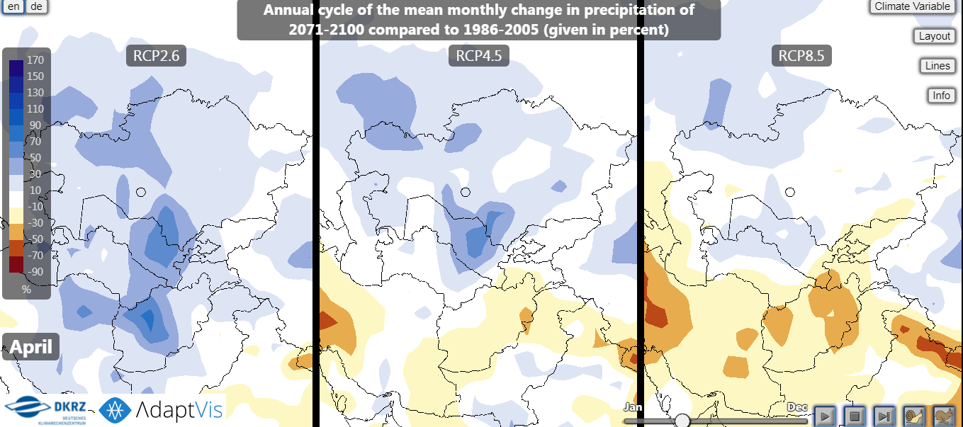
Adapted from https://www.dkrz.de/webvis/

Third national communication to the UNFCCC to include updated time series of GHG emissions 1990-2012 In 2010-2012 total emissions were 200 million tonnes of CO2-eqv and 6.5 tonnes per capita Almost 90 per cent of GHG emissions originate in the energy sector Non-CO2 gases contribute about half of the total emissions.

