Guidelines on Safeguarding Native Tree Species for Conservation of Genetic Biodiversity in Central Asia

23 September 2021

Content

Abbreviations iii
Acknowledgements iv
Executive Summary v
1. Introduction 1
1.1. Objectives of the Guidelines 1
1.2. Target Groups 2
2. Conservation of Forest Genetic Resources 2
2.1. Global Architecture 2
2.2. Regional Architecture 4
3. Status and Distribution of Native Tree Species in Central Asia 7
4. Conservation of Native Tree Species in Central Asia 10
4.1. Threats to Forests and Native Tree Species 10
4.2. Conservation Methodologies for Native Tree Species 10
4.3. Examples and Best Practices for the Conservation of Native Tree Species 13
5. Seed Harvesting in Central Asia 17
5.1. Introduction 17
5.2. Planning for Seed Harvesting 17
5.3. Identification of Native Tree Species Stands for Seed Harvesting 18
5.4. Seed Harvesting Techniques/Methods 20
5.5. Examples from Native Tree Species 24
6. Conclusion and Recommendations 26
Annexes 28
Annexe 1: Map of Central Asia 28
Annexe 2: Distribution Maps of the Selected Native Tree Species in Central Asia 29
Annexe 3: Short-term Threat Maps of the Selected Native Tree Species in Central Asia 36
Annexe 4: Combined Threat Maps of the Selected Native Tree Species in Central Asia 43
Annexe 5: Ecoregion Maps of the Selected Native Tree Species in Central Asia 50
Annexe 6: Fundamentals for Selecting Sites for Establishing Propagation Sites and Nurseries 63
Type of the nursery 64
Location (Site selection) 64
Space availability and size 64
Climate 65
Soil 65
Water supply for irrigation and water quality 65
Electricity 65
Availability of labour 65
Shelter and fencing 65
Topography and aspect 65
Seedling demand and production types 66
Ownership 66
Accessibility 66
Telecommunication 66
Access and Transport 66
Infrastructure and facilities 66
Machinery, tools and equipment 66
Annexe 7: Seed Transfer Zones and Nurseries Required in Central Asia 67
Annexe 8: Seed Transfer Zone Maps of the Selected Tree Species in Turkey 69
Annexe 9: Fruit and Cone Maturity and Other Characteristics of Native Tree Species 74
Annexe 10: Seed Characteristics of Native Tree Species 75
Annexe 11: Glossary 76
Annexe 12: References 78

Abbreviations

CACs Central Asian Countries
CBD Convention on Biological Diversity
CITES Convention on International Trade in Endangered Species of Wild Fauna and Flora
cm Centimetre
DNA Deoxyribonucleic acid
FAO Food and Agriculture Organization of the United Nations
GMAL Geneva Malus
GSPC Global Strategy for Plant Conservation
GRIN Germplasm Resources Information Network
HCVF High Conservation Value Forests
IBPGR International Board for Plant Genetic Resources
IPBES Intergovernmental Science-Policy Platform on Biodiversity and Ecosystem Services
IPCC Intergovernmental Panel on Climate Change
ITPGRFA International Treaty on Plant Genetic Resources for Food and Agriculture
IUCN International Union for Conservation of Nature
kg Kilogram
km Kilometre
m Meter
M.Sc. Master of Science
NBSAPs National Biodiversity Strategies and Action Plans
NPGS National Plant Germplasm System
NWFPs Non-Wood Forest Products
OGM General Directorate of Forestry of Turkey
OMO Chamber of Forest Engineers of Turkey
PGRU Plant Genetic Resources Unit
PI Plant Introduction
SDGs Sustainable Development Goals
SEC FAO Sub-regional Office for Central Asia
SFM Sustainable Forest Management
UNDP United Nations Development Programme
UNESCO United Nations Educational, Scientific and Cultural Organization
USD United States Dollar
USDA United States Department of Agriculture
% Percentage
ºC Degree Celsius

Acknowledgements

The Chamber of Forest Engineers of Turkey (OMO) compiled the “Guidelines on Safeguarding Native Tree Species for Conservation of Genetic Biodiversity in Central Asia” in close cooperation with Food and Agriculture Organization of the United Nations (FAO) Sub-regional Office for Central Asia (SEC).

Data, information, material and documentation collection on conservation of forest genetic biodiversity, status, distribution and conservation of native tree species and seed harvesting in Central Asia was conducted between 10 May and 30 June 2021 through literature review from online sources and databases.

The Guidelines aim at compiling and systematising relevant and up to date information on conservation of forest genetic biodiversity, status, distribution and safeguarding native tree species and seed harvesting in Central Asia.

The Guidelines are the result of a collective effort. OMO would like to express its gratitude to the FAO-SEC for its leadership and guidance during the development of the Guidelines and the technical staff of Kazakhstan, Kyrgyzstan, Tajikistan, Turkmenistan, and Uzbekistan. They also shared their thoughts and contributions to safeguarding native tree species for conserving genetic biodiversity in Central Asia with the OMO team.

OMO would like to thank Ms Claire Gallacher for identifying priority areas for the conservation of the intraspecific variation of native tree species, including the distribution maps of the native tree species stands suitable for seed harvesting in Central Asia through the Master of Science (M.Sc.) thesis, which constituted a baseline for the Guidelines.

The views expressed in this information product are those of the author(s) and do not necessarily reflect the views or policies of FAO.

Executive Summary

Central Asia is the centre of origin and diversity for many species of global importance, including fruit and nut trees. Although forests cover only 5.7% of the total land area, native tree species play a crucial role in the region by providing high genetic biodiversity. Nevertheless, 46 out of 96 native tree species are globally threatened with extinction, according to the Red List of the International Union for Conservation of Nature (IUCN). Hence, it is essential to facilitate concerted efforts to overturn this unfavourable situation as soon as possible.

Globally, solutions for conserving genetic biodiversity were initiated by the Convention on Biological Diversity (CBD), which entered in force on 29 December 1993. Additionally, the International Treaty on Plant Genetic Resources for Food and Agriculture, Nagoya Protocol on the Access to Genetic Resources and the Fair and Equitable Sharing of Benefits Arising from their Utilisation and the 2030 Agenda for Sustainable Development were concluded to support the conservation and sustainable use and utilisation of genetic resources.

Regionally, biodiversity conservation has always been on the environmental agenda of Central Asian Countries. As a result, governments have developed policies, strategies, action plans and national targets to support the global conservation efforts. For example, Kazakhstan has developed the National Strategy and Action Plan on Conservation and Sustainable Use of Biological Diversity and the Strategic Development Plan until 2025; Kyrgyzstan has elaborated A New Concept of Improving the Forestry Sector until 2040 and a National Action Plan for the Development of the Forestry Sector until 2023; Tajikistan has approved the Strategy for the Forestry Sector Development until 2030; Turkmenistan has put in force the Strategy and Action Plan on Biodiversity Conservation; and Uzbekistan has prepared the National Biodiversity Strategy and Action Plan 2018-2027.

To support the global and regional efforts, the presented Guidelines offer further solutions on safeguarding selected native tree species and elaborate on seed harvesting techniques. The selected tree species include the following: Malus niedzwetkyana, Malus sieversii, Pyrus korshinskyi, Pyrus tadshikistanica, Prunus armeniaca, Juglans regia, Pistacia vera, Juniperus semiglobosa, Juniperus seravschanica, Juniperus turkestanica, Picea schrenkiana, Betula tianschanica, Fraxinus sogdiana and Haloxylon sp.

The theoretical part of the Guidelines intends to serve as a reference for drafting the regional strategy for developing the seed sector in a comprehensive, environmentally sustainable, and socially equitable manner. Such regional strategy can be recognized as an umbrella for the establishment of a seed system. The system will ensure that high-quality seeds of native tree species are produced and fully available in time and affordable to all stakeholders. The Guidelines can support the creation of a regional technical network to facilitate policy alignment, cooperation and coordination in the wider area of sustainable management of plant genetic resources, including on sets of rules for regulatory frameworks such as seed quality protocols, seed production and delivery standards, seed security, rehabilitation activities using native genetic materials and seed marketing in the long term.

The practical part of the Guidelines is centred around two basic strategies available to conserve genetic biodiversity: in situ and ex situ. In situ conservation refers to conserving ecosystems and natural habitats and maintaining and recovering viable species populations in their natural surroundings. Ex situ conservation refers to conserving biodiversity outside their natural habitats. When implemented in parallel, in situ and ex situ strategies complement each other to conserve native tree species (inter-specific) and intra-specific genetic variations. While in situ conservation allows natural evolutionary processes to continue through adaptation to changing conditions, ex situ conservation could be an option if species or populations are threatened in the wild.

Historically, establishing protected areas to conserve particular tree species is one of the best examples of in situ conservation. However, in Central Asia, the distribution range of the selected native tree species is not well represented in protected areas. Hence, in addition to protected areas, consideration of managed forests and trees outside of forests supports in situ conservation in situations where the conservation of genetic biodiversity may not be the premium priority objective. Ecosystem and landscape-based conservation approaches provide a holistic perspective to safeguard genetic biodiversity in natural and fragmented habitats. A practical conservation approach to support the multi-functions of native tree species (i.e. production of goods and services such as timber, fuel wood, fruits and habitat for pollinators) is sustainable forest management in forestlands or integrated/sustainable land management in other lands with trees. A targeted species-specific conservation approach could be adopted and implemented for those native tree species that need urgent action. Tree breeding programmes are valuable tools for conserving genetic biodiversity by mitigating and adapting to climate change. Rich species diversity will typically increase the resilience to climate change. Conservation efforts may also focus on conserving particular adaptive traits found in provenance research of native tree species, such as resistance to pests, diseases, temperature, moisture or drought. Assisted migration of native tree species inside the native range includes managed movement of well-adapted species to areas where they are not yet present by introducing better-suited populations selected from existing distribution areas. Tree-specific action and management plans for the native tree species outside forests and ecosystem-based multi-functional forest management plans could play a key role by defining assisted natural regeneration, afforestation, reforestation, restoration and rehabilitation activities to conserve genetic biodiversity. Cooperation with local farmers would be crucial because they rely on goods and services provided by the native trees for their livelihoods.

Good quality seed harvesting from the native tree species could be the first step of ex situ conservation measures to conserve genetic biodiversity outside of natural habitats and assist in situ conservation measures by collecting reproductive material. Seeds can be harvested from natural populations, managed populations and cultivated tree seed stands or seed orchards of single or multiple tree species. It is crucial to collect seeds locally and from natural populations to conserve gene flow and genetic biodiversity.

Introduction

Forests cover 31.1% of the total lands or 4.1 billion hectares and occupy more than three-quarters of terrestrial biodiversity around the globe (FAO, 2020a; FAO and UNEP, 2020). However, forests cover 5.7% of the total land in Central Asia, representing a low forest cover compared to the world’s average. More specifically, forest covers 1.3% of Kazakhstan, 6.9% of Kyrgyzstan, 3.1% of Tajikistan, 8.8% of Turkmenistan and 8.7% of Uzbekistan.

Although forest cover is low in Central Asia, the high genetic biodiversity of species (Eastwood et al., 2009) attaches great importance to this region by providing habitats for native tree species, including wild fruit and nut tree species in forests and outside forests. Native tree species are critical elements of the forests and other lands with trees that provide social, environmental and economic goods and ecosystem services.

For example, native tree species provide habitats for genetic biodiversity, offer wood products, sequester carbon, produce oxygen and non-wood forest products (NWFPs). Moreover, they support soil and water conservation, pollination, climate resilience, erosion, landslide and flood control, ecotourism and human mental and physical health. Furthermore, they provide fodder for livestock, contribute to food security, nutrition and agriculture, improve employment and income for livelihoods and have social, cultural, spiritual and heritage values.

Central Asia provides habitats for 96 native tree species on the Red List of the IUCN, and 46 of these native tree species are globally threatened with extinction (Eastwood et al., 2009). Besides, overgrazing, collecting fuelwood, illegal logging, over-harvesting of NWFPs, fires and climate change are considered human-induced and natural threats to native tree species (Eastwood et al., 2009; Gaisberger and Loo, 2017). Hence, it is essential to conserve and sustainably manage genetic biodiversity by safeguarding the native tree species under the threats for their survival, sustainability of forest goods and ecosystem services, climate resilience and social and cultural values.

Objectives of the Guidelines

The Guidelines on Safeguarding Native Tree Species for Conservation of Genetic Biodiversity in Central Asia primarily considers the distribution of selected native tree species and offers recommendations and measures on safeguarding native tree species, including the techniques for seed harvesting. In addition, the Guidelines will support the elaboration of a regional strategy for the seed system development to develop the seed sector comprehensively, environmentally sustainable, and socially equitable. A seed system ensures that high-quality seeds of native tree species are produced and fully available in time and affordable to all stakeholders.

Moreover, the Guidelines will support establishing a regional technical network to facilitate policy alignment, cooperation and coordination for sustainable management of the plant genetic resources and seed systems and promoting resilience of the food systems under climate change in the context of the Convention on Biological Diversity (CBD) and the International Treaty on Plant Genetic Resources for Food and Agriculture (ITPGRFA).
The Guidelines will support the FAO Member States in Central Asia, providing best practice examples to work together to support common development objectives to promote local, cost-effective, and proven solutions. Such solutions can support capacity development in the other FAO Member States. Moreover, the Guidelines will improve policies to achieve the Sustainable Development Goals (SDGs), enhance progress in reaching common development objectives and strengthen the capacities of government officials on policy and strategy development. The Guidelines will support informed and evidence-based decision-making by demonstrating techniques and technologies used to conserve genetic biodiversity by safeguarding native tree species and seed harvesting.

The Guidelines provide general methods for safeguarding selected native tree species and seed collection from these species to conserve and maximise genetic biodiversity.

When using the Guidelines, Central Asian countries (CACs) are invited to consider gender equality and women’s empowerment and the role of local farmers in safeguarding native tree species.

The Guidelines is a dynamic product and could be expanded by including new native tree species in the future through increased capacity and knowledge in Central Asia.

Finally, the Guidelines will serve as a model for safeguarding native tree species to conserve genetic biodiversity beyond Central Asia, leading to broader replication of the Guidelines with different native tree species for other regions such as the Caucasus, Mediterranean and Balkans.

Target Groups

The Guidelines aim to facilitate the progress in safeguarding native tree species for conserving genetic biodiversity in Central Asia to ensure enhanced biodiversity conservation actions in the forestry sector, providing spatial distribution of prioritised native tree species and proposing methods and recommendations for conserving forest genetic biodiversity and seed harvesting.

Understanding such diverse targets of the Guidelines, the broad range of primary and secondary audiences should be included in the scope. The primary gender-balanced audience is the Governments, the public and private sector, local communities, and farmers. Cooperation with these groups supports safeguarding native tree species since they provide goods and services for the local communities through income generation and improving livelihoods. In addition, the Guidelines may be used for national and global research institutions, international funds, academic society, environmental non-governmental organisations, and trade unions.

The benefits for these groups include providing good quality analytical inputs to safeguard the native tree species for conserving forest genetic biodiversity. The strategic planning is based on the distribution of native tree species in Central Asia and natural and human-induced threats to identify key biodiversity conservation priorities in the forestry sector.

Conservation of Forest Genetic Resources

Global Architecture

Forests and trees outside forests are affected by the global changes and increasing demands by the communities (FAO, 2010). Forests and trees outside forests are essential resources by providing habitats for conserving genetic biodiversity. Nevertheless, unsustainable forest management, deforestation, and forest/land degradation create new challenges for conserving genetic biodiversity. In this sense, various international efforts included in the preceding paragraphs have been initiated to protect forests, trees outside forests and forest genetic biodiversity.

The Convention on Biological Diversity (CBD) entered into force on 29 December 1993. The main objectives of the Convention are to conserve biological diversity, sustainable use of the components of biological diversity and fair and equitable sharing of the benefits arising out of the utilisation of genetic resources (UN, 1992). In this regard, CBD established an international legal framework to conserve and use biodiversity, including domesticated and non-domesticated species used for food and agriculture, sustainably and share the benefits arising from using genetic resources fairly and equally (FAO, 2019a).

The International Treaty on Plant Genetic Resources for Food and Agriculture (ITPGRFA ) aims to conserve and ensure the sustainable use of plant genetic resources for food and agriculture and the fair and equitable sharing of the benefits arising from their use (FAO, 2009).

The Global Strategy for Plant Conservation (GSPC ), adopted in 2002, is a program of the CBD that seeks to slow the pace of plant extinction through five objectives and 16 associated targets.

In 2010, the Nagoya Protocol on the Access to Genetic Resources and the Fair and Equitable Sharing of Benefits Arising from their Utilisation (CBD, 2011) was adopted as a supplementary agreement to the CBD.

Later, Strategic Plan for Biodiversity 2011-2020, including Aichi Biodiversity Targets, was adopted in 2010 by providing an inclusive framework on biodiversity and promoting sustainable development. Aichi Biodiversity Targets comprises 20 targets that address each of the five strategic goals defined in the Strategic Plan. In this regard, Strategic Goal C of the Strategic Plan aims to improve the status of biodiversity by safeguarding ecosystems, species and genetic biodiversity (CBD, 2021).

In 2012, the Intergovernmental Science-Policy Platform on Biodiversity and Ecosystem Services (IPBES) was established as an independent intergovernmental body to conduct objective scientific assessments on the planet’s biodiversity and ecosystems, the benefits they provide to people, and the tools and methods available to protect and sustainably use biodiversity and ecosystems (FAO, 2019a).

The Global Plan of Action for the Conservation, Sustainable Use and Development of Forest Genetic Resources identified 27 strategic priorities in 2013. The Action Plan mainly focuses on four thematic areas: (i) improving the availability of, and access to, information on forest generic resources, (ii) conservation of forest genetic resources, (iii) sustainable use, development and management of forest genetic resources, and (iv) policies, institutions and capacity-building (FAO, 2014c).

The Second Global Plan of Action for Plant Genetic Resources for Food and Agriculture includes 18 priority activities, which provides specific references to farmers’ varieties/landraces to strengthen their improvement and management on the farm; enhance their documentation and conservation ex situ; create a better understanding of their value and potential use in breeding programmes; assess genetic erosion and threats; promote their development and commercialisation;
Moreover, develop management strategies for these activities.

FAO’s Voluntary Guidelines for the Conservation and Sustainable Use of Farmers’ Varieties/Landraces aims to develop and strengthen the conservation and sustainable use of farmers’ varieties/landraces.

More recently, FAO developed the Strategy on Mainstreaming Biodiversity across Agricultural Sectors and an Action Plan for 2021-2023 (FAO, 2020b, 2020c). The objectives of the Strategy are mainstreaming biodiversity across agricultural sectors at various levels in a structured and coherent manner by considering national priorities, needs, legislation and strategic documents; reducing the adverse impacts of agricultural activities on biodiversity; promoting sustainable agriculture and conserving, enhancing, preserving and restoring biodiversity (FAO, 2020b).

The 2030 Agenda for Sustainable Development, adopted by all United Nations Member States in 2015, introduced seventeen SDGs towards sustainable development as the overarching effort. The SDGs have great relevance for biodiversity, including:

- Zero Hunger (SDG2) aims to maintain the genetic biodiversity of seeds, cultivated plants, and their related wild species through soundly managed and diversified seed and plant banks.
- Life on land (SDG15) aims to ensure the conservation, restoration and sustainable use of terrestrial and inland freshwater ecosystems and their services, in particular forests, wetlands, mountains and drylands; promote the implementation of sustainable forest management, halt deforestation, restore degraded forests and substantially increase afforestation and reforestation globally.

The following section analyses the efforts related to safeguarding native tree species, according to the international agreements and actions conducted to conserve forest genetic biodiversity in Central Asia.

Regional Architecture

Nature conservation has always been on the environmental agenda of Central Asian Countries (CACs). The most important international treaties related to the conservation of biological diversity and the use of traditional knowledge have been ratified by all five republics: CBD (Kazakhstan - 6 September 1994; Kyrgyzstan - 6 August 1996; Tajikistan - 29 October 1997; Turkmenistan -18 September 1996; Uzbekistan - 19 July 1995) and the United Nations Educational, Scientific and Cultural Organization (UNESCO) Convention for the Safeguarding of Intangible Cultural Heritage (2003). The Kyrgyz Government has also ratified the International Treaty on Plant Genetic Resources for Food and Agriculture (2004).

Forests resources in Central Asia significantly impact the local livelihoods, depending on them by collecting firewood, timber, and food (nuts, fruits, producing honey, other NWFPs, livestock grazing or forage production) (FAO, 2020d). It continuously caused an anthropogenic load on the region's forest resources, negatively affecting native forest biodiversity. Since the Soviet period, the limited forest areas had set aside conservation areas with limited or no logging activities. Currently, the Governments of CACs have maintained this status by prohibiting commercial logging and increasing natural reserves as well as attempts to introduce the High Conservation Value Forests (HCVF) concept (i.e., on-going United Nations Development Programme (UNDP) Projects in Kazakhstan and Kyrgyzstan). The institutional structures of the protected area management have been inherited from the old Soviet system, and CACs use this system with three critical variations of protected area statuses (Eastwood, 2009):

- Zapovednik reserves (strictly protected reserves) – have the highest level of protection (IUCN Category I), where only scientific research is allowed,
- National nature parks (IUCN Category II) – are designed to preserve natural complexes of ecological, cultural and aesthetic importance, mainly dedicated for conservation, recreation, scientific or cultural purposes,
- Zakazniks (sanctuaries or particular purpose reserves) include natural monuments (IUCN Category III) and offer a broader range of opportunities for various land use options.

Similarly, all national biodiversity conservation programs in CACs have the former Soviet approach of using national Red Data Books to determine the main directions of conservation policies. These lists of endangered species document the rare and endangered species, which were adjusted following the IUCN Red Lists almost in all CACs. Protection of forest areas of a high cultural value has a special status of UNESCO Biosphere Reserves. The instances of such areas established by CACs are Sary Chelek Biosphere Reserve (23,868 ha) in Kyrgyzstan, Mount Chatkal Biosphere Reserve (35,255 ha) in Uzbekistan and the Repetek State Biosphere Reserve (34,600 ha) in Turkmenistan (Lapena et al., 2014).

Kazakhstan defined the national targets and strategic activity planning related to forest biodiversity conservation in the National Strategy and Action Plan on Conservation and Sustainable Use of Biological Diversity and the Concept on Transition towards Green Economic until 2050. The Strategic Development Plan of the Republic of Kazakhstan until 2025 sets a biodiversity conservation objective, where increasing forest areas is a direct approach. The detailed objectives are stated in the new Strategic Plan of the Ministry of Ecology, Geology and Natural Resources of Kazakhstan 2020-2024. The mechanism of the forest biodiversity conservation strategy indicated in these documents primarily focuses on increasing the protected forest areas. However, no specific activities were indicated considering the ex situ or in-situ native tree conservation approaches.

The legal framework for the forestry sector development in Kyrgyzstan is regulated by the Forest Code of the Kyrgyz Republic, A New Concept of Improving the Forestry Sector of the Kyrgyz Republic until 2040 and a National Action Plan for the Development of the Forestry Sector in the Kyrgyz Republic for five years until 2023. The New Concept indicates the necessity to elaborate Guidelines for seed production and seedling growth by establishing nurseries and forest seed units to further establish plantations with the native trees and improve natural forest regeneration.

The national priorities for sustainable use of natural resources and ecological resilience in Tajikistan are indicated in the National Strategy for the Development of Tajikistan for 2016-2030. The Forest Code regulating the forestry sector and the Law on Environment Protection came into force in 2011. The Strategy for the Forestry Sector Development of the Republic of Tajikistan until 2030 and the related Action Plan for 2021-2025 regulate the national policy on forest biodiversity conservation. Mechanisms of forest conservation activities are mainly related to poverty alleviation goals for the local forest-dependent population, improvement of the Community Based Forestry principles, increased protection of forest resources, limitations on logging, and increasing protected forest areas. No specific activities related to the ex situ or in-situ native tree conservation approaches are indicated.

Turkmenistan emphasised a higher role of being part of the CBD since 1996, Cartagena Protocol of CBD since 2008, and Ramsar Convention on wetlands since 2009, and highlight them as leading documents for national biodiversity conservation strategies in the Fifth National Report on CBD of Turkmenistan. In this view, the Strategy and Action Plan on Biodiversity Conservation of Turkmenistan (2002) is a crucial document setting the national objectives in the country. A priority of preserving the native forests in Turkmenistan was set in 2013 in the National Forest Program of Turkmenistan, and an Action Plan on increasing the forest areas until 2020. The Forest Code came into force in 2011 and became the principal legal document for the forestry sector. The Strategy and Action Plan on Biodiversity Conservation of Turkmenistan (2002) indicate that the Ashgabat Botanical Garden hosted a genetic seed bank of nearly 3,000 species, mainly Turkmenistan’s flora.

Moreover, the Strategy provides details of in situ and ex situ conservation objectives. In situ activities are focused on improving the management systems and increasing the protected areas. Ex situ activities mention the logistical and infrastructural support to the Garrygala Scientific-Production Experimental Centre for Genetic Resources' live collections and support breeding centres to conserve wild plant species, vital for agrobiodiversity. The Action Plan considers promoting the genetic biodiversity of fruit plants and their wild relatives and creating plant seed banks and germplasm banks. The mechanisms include developing legislation on management and regulation and providing logistical support to create a forest plant germplasm bank. The document also mentions creating new and improved existing breeding centres for rare and threatened plant species. Fifth National Report on CBD of Turkmenistan in 2014 reported that 50% of these objectives on in situ conservation was realised, and 66.6% of the planned objectives for ex situ conservation was realised.

In Uzbekistan, the National Biodiversity Strategy and Action Plan 2018-2027 (NBSAPs) guides the biodiversity conservation policy, setting national targets and objectives for conservation and sustainable use of biodiversity, including the forest sector. As stated in the Fifth National Report on CBD of the Republic of Uzbekistan, several strategical documents have been developed, such as the long-term Strategy of National Development “Vision 2030”, National Programme for Combating Desertification, Land Degradation and Drought, and Programme for Forestry Development. The key objectives of these documents are the provision of sustainable use of the environment and natural resources in Uzbekistan and their adequate protection to ensure its economic prosperity. Biodiversity conservation and sustainable use of biological resources are recognised as one of the most critical conditions of ecological sustainability. Another resolution on “Concept of Development of Botanical Garden in 2014-2017” sets the goal of enhancing the ongoing research activities related to the conservation of flora in the Botanical Garden.

Status and Distribution of Native Tree Species in Central Asia

FAO-SEC supports the Member Countries to promote the resilience of food systems under climate change per the national commitments in CBD and the Treat on Plant Genetic Resources for Food and Agriculture. Facilitation of policy alignments and fostering cooperation and coordination within-country agencies and across countries in the region are fundamental approaches used by FAO-SEC in meeting these international and national commitments for the sustainable management of the plant genetic resources and seed systems.

As part of these activities, research (Gallacher, 2020) supported by FAO-SEC combined five key steps to obtaining the necessary status and spatial distribution of the selected native tree species. Analysis was conducted based on forest and woodland types in Central Asia (Figure 1): Broadleaved fruit and nut forests, pistachio woodlands, juniper woodlands, Taiga forests, riparian Tugai and Saxaul shrublands (Eastwood et al., 2009; Cooley, 2014; Thevs, 2018 cited in Gallacher, 2020).

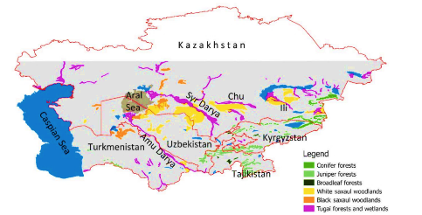
Figure 1. Distribution of different forest types in Central Asia (Rachkovskaya et al., 2003)

Broadleaved fruit and nut forests are in the foothills and slopes of the Tien Shan, Pamir-Alai and Kopet Dag mountains between 800–2000 m consisting of walnut, apple, pear, plum, and almond forests. Pistachio woodlands are on the lower, drier foothills and slopes of western Tien Shan, Pamir-Alai and Kopet Dag mountains. A notable example of the pistachio woodlands is the Badghyz Strict Nature Reserve in Turkmenistan, covering 76000 ha. Juniper woodlands/shrublands are in the dry foothill regions or mid to high altitudes up to 3,500 m. Taiga forests comprising predominantly spruce and fir species are restricted to the northern slopes of the Tien Shan between 1700 m and 2700 m. Riparian Tugai is restricted to the region's floodplains, alongside river courses and streams, including willow, poplar and birch trees. Saxaul shrublands can be in the desert and arid steppe regions, mainly Turkmenistan and Kazakhstan, essential for soil conservation (Eastwood et al., 2009).

Central Asia is home to around 450 forest, fruit and nut tree species. Based on IUCN Red List categories, literature findings, data and information availability and expert guidance, the Guidelines focus on the following selected native tree species:
- Malus niedzwetkyana,
- Malus sieversii,
- Pyrus korshinskyi,
- Pyrus tadshikistanica,
- Prunus armeniaca,
- Juglans regia,
- Pistacia vera,
- Juniperus semiglobosa,
- Juniperus seravschanica,
- Juniperus turkestanica,
- Picea schrenkiana,
- Betula tianschanica,
- Fraxinus sogdiana and,
- Haloxylon sp.

Since the Guidelines focus on selected native tree species, the first step was to have information about their status and distribution in the region. The species distribution modelling predicts a species' possible future spatial distribution based on past, present and future scenarios. The method explores the relationship between the geographical occurrences of the selected species and environmental variables in the regions by using computer algorithms.

The threat mapping was the second phase based on a framework developed by Gaisberger et al. (2017; 2020) to assess at the population level where multiple threats may impact suitable habitat and thus the potential distribution of the priority species in the short term (i.e., overgrazing, human impacts, fires) and long term (i.e., climate change). The literature and expert assessments stated three immediate threats of overgrazing, fuelwood cutting, and uncontrolled logging as the most crucial causes of forest degradation in Central Asia (Borchardt et al., 2009 cited in Gallacher, 2020; Canterello et al., 2014; Thevs, 2018). These threats have led to severe habitat fragmentation and the loss of around 90% of forests over the last half-century (Cooley, 2014; Thevs, 2018 cited in Gallacher, 2020).

The ecoregion mapping phase identifies areas for the in situ and ex situ conservation of genetic resources and collecting germplasm samples (Parra-Quijano et al., 2017). This ecogeographic approach analysed the relationship between species distribution and the ecogeographic zones or ecoregions (Aravanopoulos, 2016). Specific ecoregion maps or “ecogeographic land characterisation maps” were prepared using CAPFITOGEN’s “ELCS mapas” tool (Version 1.2).

Ecoregion
An ecoregion is a relatively large land or water area that contains a geographically distinct assemblage of natural communities. These communities share a large majority of their species, dynamics, and environmental conditions. Ecoregions function effectively as conservation units because they encompass similar biological communities and because their boundaries roughly coincide with the area over which key ecological processes most strongly interact. These features can help conservation planners better achieve representation and persistence of biodiversity when developing conservation strategies for individual ecoregions. (WWF webpage) .
Text Box 1.Ecoregion definition by WWF

The calculation of the vulnerable areas to short-term and long-term threats based on the potential loss percentage revealed that selected native tree species would lose area in variable amounts. While the predicted average area lost due to combined short-term threats was 37.3%, the predicted average area lost due to climate change was estimated as 12.7%.

The most threatened species based on danger are Pistacia vera, Pyrus korshinskyi, Malus niedzwetzkyana, Pistacia vera, Picea schrenkiana, Malus sieversii, Pyrus korshinskyi, Picea schrenkiana, Prunus armeniaca and Betula tianschanica, respectively. Short-term threats pose more significant challenges for safeguarding native tree species than climate change. The threats would impact the future intraspecific variation of the species and consequently genetic biodiversity due to the loss of ecoregions. On the other side, new areas will become suitable for native tree species with an average gain of 33% of current distribution areas (Gallacher, 2020), which could be a potential for future afforestation, reforestation and restoration activities.

As a result, final maps for each selected native tree species were created, combining both the projected effects of short-term threats and climate change to provide the basis for recommendations on safeguarding native tree species to conserve genetic biodiversity. Final maps include: “status and distribution maps”, “short-term threats maps”, ``combined threat maps”, and “ecoregion maps” (Please see Annexe 2-5 for the maps) (Gallacher, 2020). The maps include protected areas and visualise the percentage of the species distribution which are currently protected to indicate the current conservation status. Analysis revealed that 16.2% of the distribution area of Betula tianschanica is currently protected. On the contrary, only 0.7% of the distribution area of Pyrus tadshikistanica is protected. On average, for all selected native tree species, only 7.6% of their total potential distribution is currently protected (Gallacher, 2020).

Knowing the status and spatial distribution of native tree species by considering the potential threats and their intraspecific variation could be an input or indication for developing strategies for safeguarding these species to conserve their genetic biodiversity and successful seed harvesting (Gallacher, 2020).

In this context, the following section offers recommendations for safeguarding native tree species to conserve forest genetic biodiversity in Central Asia.

Conservation of Native Tree Species in Central Asia

Threats to Forests and Native Tree Species

Central Asia is a unique region and home to hundreds of native tree species and cultivated tree varieties (Lapeña et al., 2014). For example, more than 8,000 plant species exist in Central Asia, and more specifically, Uzbekistan alone is home to 83 varieties of apricot, 40 apples, 30 walnut and 15 pears. In other words, Central Asia could be named as a “living gene bank”. The rich genetic biodiversity allows native tree species and their varieties to cope with climate change and enable breeding of other varieties suitable for cultivation (CGIAR, 2015).

On the other side, human-induced threats pose serious area and habitat loss, including loss of genetic biodiversity in forests and trees outside forests. In particular, fruit and nuts forests and trees outside forests are under exploitation, subject to land degradation, erosion, salinity in soils, overgrazing, overuse, illegal cutting, firewood collection, fires, pest and diseases attacks. Expanding settlements and agriculture, collecting rootstocks for grafting, and spreading invasive species from country houses are other problems (Lapeña et al., 2014; CGIAR, 2015; Thevs, 2018; Gallacher, 2020). The decrease in species' population size could result in land degradation, malnutrition, and a decrease in fruit and nuts production. Population increases, and consequently, the demand for food and nutrition will continue to pressure forests and trees outside forests in Central Asia.

Moreover, the Intergovernmental Panel on Climate Change (IPCC) projected a 3.7ºC temperature increase (IPCC, 2007a) and a decrease in mean precipitation in Central Asia that will be accompanied by an increase in the frequency of arid spring, summer and autumn seasons (IPCC, 2007b). For example, in Tajikistan, recent heavy spring rains destroyed the blossoms of Malus sieversii in 2019, which decreased fruit production (Miravalova et al., 2020). Different forest types and varieties, populations, and tree species may respond differently to climate change. In such conditions, safeguarding the native tree species for the future longer-term perspective is an indispensable prerequisite of conserving genetic biodiversity.

Conservation Methodologies for Native Tree Species

Conservation of genetic biodiversity can be defined as the policies and management actions taken to ensure the existence, availability and sustainability of native tree species. Policies and management could include scientific research, strategy, methodology and programme development, field trials, and breeding programmes. In general, two basic strategies are available to conserve genetic biodiversity: in situ and ex situ.

In situ conservation refers to conserving ecosystems and natural habitats and the maintenance and recovery of viable populations of species in their natural surroundings (on-site/in place/on-farm) (i.e., seed stands, plus trees, native tree stands, natural forests, protected areas, dynamic genetic conservation units). Ex situ conservation refers to conserving biodiversity outside their natural habitats. Examples for ex situ conservation could be arboretums, botanic gardens, planted forests, ex situ gene conservation tree stands, tree breeding programmes, seed/gene/field banks, seed orchards, in vitro/pollen/DNA storage and clonal archives (UN, 1992; FAO, FLD, IPGRI, 2004a, 2004b). When implemented in parallel, in situ and ex situ strategies complement each other to conserve native tree species (inter-specific) and intra-specific genetic variations. While in situ conservation allows natural evolutionary processes to continue through adaptation to changing conditions, ex situ conservation could be an option if species or populations are threatened in the wild (FAO, FLD, IPGRI, 2004a; FAO, 2021b).

Historically, establishing protected areas is one of the best examples of in situ conservation by providing habitats for conserving a particular tree species (FAO, DFSC, IPGRI, 2001). However, in Central Asia, the distribution range of the selected native tree species are primarily out of the protected area systems, or they are not well represented in protected areas (Gallacher, 2020). Hence, in Central Asia, safeguarding native tree species should cover protected areas and managed forests and trees outside forests to support in situ conservation actions where conservation of genetic biodiversity may not be the priority objective. In this respect, safeguarding native tree species for conservation of genetic biodiversity should be integrated and mainstreamed to the management of all land-use categories containing trees with strengthened coordination between national institutions, research institutes, academia, non-governmental organisations, private sector, local communities, farmers and other possible relevant stakeholders by considering human and financial resource availability and technical and technological capacities.

Ecosystem and landscape-based conservation approaches and management systems provide a holistic perspective to safeguard different native tree species and their genetic biodiversity in natural habitats. The ecosystem and landscape-based conservation approach are well suited to lowland areas with high tree species diversity by ensuring the existence and sustainability of local populations of native tree species with social, cultural, environmental and economic functions.

Human populations demand various goods and services from the native fruit and nut tree species, especially in lowlands, for their livelihoods. Therefore, sustainable forest management or integrated/sustainable land management under climate change conditions could also be considered a practical conservation approach to support the multi-functions of native tree species to produce sustainable goods and services in forests and outside forests.

Since not all native tree species, including Saxaul, are rare or endangered, or some native tree species and their stands, populations need urgent action. A targeted species-specific conservation approach could also be adopted and implemented to save resources and time. On the contrary, some native tree species have less use and economic value and are often neglected. In this case, set the priority objectives. Target native tree species should be selected for intra-specific conservation of different populations based on various criteria such as their distribution ranges in nature, rareness and endangered level, endemicity, plantation programmes, contribution to economy, social and environmental values.

Tree breeding programmes are also valuable tools for conserving genetic biodiversity and climate change mitigation and adaptation. Rich species diversity will increase the resilience of improved native tree species under climate change. Tree breeding programmes could facilitate growing improved native tree species to tackle climate change (FAO, 2015).

Conservation efforts may also focus on conserving particular adaptive traits/provenance research of native tree species, such as resistance to pests, diseases, temperature, moisture or drought. The adaptive potential of native tree species defines the tolerance or resistance of species to the changes in the environment and is determined by adaptive traits such as growth rates; stem form; seed production; tolerance to pests, drought, heat, salinity and heavy metal toxicity; and many other characteristics. Improving different traits by selection and breeding might help to ensure the necessary adaptive potential of native tree species. The size of the species population also determines the amount of genetic diversity. Small populations usually isolated by physical barriers contain a lower level of genetic diversity, whereas larger populations have more active intraspecific pollen and seed flows, ensuring a higher level of genetic diversity. Understanding patterns of variation in adaptive traits are vital in selecting suitable seed sources for different purposes. Genetic variation in the traits of native tree species is measured by experimental approaches, which separate genetic effects from the local ecological effects and further applying an appropriate statistical analysis (Boshier, 2011).

Assisted migration of native tree species includes managed movement of well-adapted species inside the native range to areas where they are not yet present and introduces better-suited populations within native tree species. Moving well-adapted populations is a better strategy than moving species to lower the collateral environmental risks if genetic variability is large. This approach requires a monitoring system at various levels for native tree germplasm and the strengthening of gene banks to meet the challenges of climate change (FAO, 2015).

Genetic resources often get less attention in planning and implementing forest management; however, conservation is crucial for sustainability (FAO, 2021b). Tree-specific conservation and management plans for the native tree species outside forests and ecosystem-based multi-functional forest management plans could play a key role by defining assisted natural regeneration, afforestation, reforestation, restoration and rehabilitation activities to conserve genetic biodiversity.

Cooperation with local farmers would be crucial because they rely on goods and services provided by the native trees for their livelihoods. Farmers are also good at identifying species and varieties of trees that meet their livelihood needs (FAO, 2015).

Considering the variety of conservation measures and selected native tree species in all CACs, the natural spatial distribution range of native tree species crosses national borders. Therefore, safeguarding native species for conserving genetic biodiversity may differ based on the policies, legislation, management and institutional structure of government organisations and financial and human resources of each country in Central Asia. However, these differences pose a regional opportunity that facilitates an enabling environment for safeguarding native tree species for conservation of genetic biodiversity through information and knowledge sharing system and technology transfer and even seed transfer; and development of standard minimum requirements for genetic conservation units of native tree species, documentation and management, evolving a database.

In this regard, as a starting point, international and national forestry experts assessed trees' conservation status in Central Asia in 2006. As a result, a list of nationally threatened tree species and a preliminary Red List of globally threatened trees from Central Asia using the IUCN Red List categories and criteria were produced. Out of 96 taxa, 44 were evaluated and categorised under threat for extinction in the wild (Eastwood et al., 2009).

Conservation of threatened native tree species is an essential task of the environmental policies of the CACs. The environmental policies focus on conserving native tree species by enhancing crop wild relatives' conservation, supporting farmers’ management of local diversity of fruit species for their conservation and continued evolution in situ, and recognising and protecting farmers’ rights (Lapeña et al., 2014). Conserving genetic biodiversity against threats is needed to survive and evolve native tree species and adapt to climate change and other dynamic environmental conditions. Moreover, conserving genetic biodiversity could support breeding and domestication programmes to develop adapted varieties or strengthen valuable traits to ensure food security and improve livelihoods. In this sense, in situ conservation, a preferred approach for forest tree species, allows dynamic maintenance of genetic biodiversity. On the other side, ex situ conservation is mainly used for domesticated tree species (FAO, 2014c).

Native tree populations are unlikely to have the capacity to migrate to other habitats under the impacts of climate change; therefore, the adaptation of in situ relies on their phenotypic plasticity and genetic diversity (FAO, 2015). The genetic resources are conventionally conserved using ex situ methods, usually by introducing seed banks. However, the longer-term regeneration processes of native tree species require a combination of in situ methods with complementary ex situ conservation methods. The selection of the necessary methods and their planning is a highly responsible process which should be done by including all interested parties on national and international levels, considering multiple factors like the biology of the selected species (Engels and Wood, 1999), practicality and feasibility of the available methods, as well as the cost-effectiveness and security afforded by its application (Maxted et al., 1997). However, the limited access to technology, infrastructure, trained staff and funding of the ex situ conservation methods are not used as widely as in situ approaches in Central Asia (Eastwood et al., 2009).

In contrast, the in situ approaches have a long species preservation history in Central Asian forestry science and species selection and breeding practices (Lapeña et al., 2014). Both options consider an appropriate collection of reproductive material for replicating selected plant species. When talking about tree species, it is usually not the only seed to be harvested for conservation, but sometimes the whole trees, tissues, or genetic material in culture. Conservation purposes, characteristics of the selected species, available infrastructure, expertise and financial resources are the factors to determine the harvesting type (FAO, FLD, IPGRI, 2004b).

Examples and Best Practices for the Conservation of Native Tree Species

Several examples are available in Central Asia for ex situ conservation that focus on wild native tree species. For example, Kazakhstan’s most extensive ex situ collection is for Malus sieversii, the primary wild ancestor to most cultivars of domestic apples, and Uzbekistan’s most prominent collections are nut-bearing trees, Juglans regia and Pistacia vera (FAO, 2014a). In Kazakhstan, two native tree species (Juniperus seravschanica and Malus sieversii) are conserved ex situ in field collections, and ex situ seed stores are also kept for these species (FAO, 2014a). Germplasm of the wild and threatened Central Asian apple species, Malus sieversii, collected in the 1990s from Kazakhstan, has shown resistance to apple scab, fire blight, drought and numerous soil pathogens (FAO, 2014a).

Another example related to the ex situ germplasm bank is the Plant Genetic Resources Unit (PGRU) in Geneva, New York, of the National Plant Germplasm System (NPGS) administered by the Agricultural Research Service of the United States Department of Agriculture (USDA). The seeds and genetic material of the wild apple species growing in Central Asia were collected from 1989 to 1996 to cover the lack of wild-growing species genetic material in the seed bank (Forsline et al., 2003). The collection and storage of the apple genetic material were supported by appropriate infrastructure and systematic documentation of the collected material. The amounts and seed harvest locations were also determined based on the purpose of the ex situ seed bank. In this case of the apple seed repository, the crucial traits were drought, frost or pest resistance of the wild species to improve the domesticated species in the future. Thus, some locations were chosen based on these characteristics (i.e., collecting seed in dry areas). In total, over 120,000 seeds were collected from randomly selected 894 trees. In addition, separate harvesting was conducted to identify trees that appeared to possess horticulturally desirable characters, which have been termed as “elites” (Forsline et al., 2003).

Isozyme analysis (Lamboy et al., 1996) was used to analyse the first batch of seed harvest to determine the levels of genetic variation within the collected M. sieversii seeds. “Based on genetic analysis of sib families from four areas, the populations of M. sieversii surveyed appear to constitute a single panmictic population with more than 85% of the total genetic variation due to differences among families and only 15% due to differences among regions. Thus, it was determined that the most efficient strategy to acquire generalised genetic diversity and potentially useful alleles would be to explore as many unique ecological niches as possible” (Forsline et al., 2003). Nine various ecosystems were determined for seed harvesting from M. sieversii based on the operation purposes. In addition, seed harvesting of wild apples in Central Asia focused on collecting seeds from high-quality trees with corresponding fruit traits. Some drought-resistant/drought-adapted species were also collected in a xerophytic area in the Karatau region. The wild apple seed harvesting showed that although the selected fruits were of similar size from the different elevations, “both the 60 random accessions and 14 elites had variable horticultural characters and levels of disease susceptibility depending on elevation” (Forsline et al., 2003).

The majority of the seed samples included random leaves and 14000 seeds from 260 trees across the nine different ecosystem niches in 1996. Fifty-four randomly selected trees were sampled for each site from an area of 3.0 km × 5.0 km with considerable variance in elevation along with diverse slopes and aspects. Population size was different for each niche and varied from 10 to 60 trees depending on the size of area and time allotted for collection at each site. Additional 14500 seeds from 47 superior or “elite” trees were collected throughout all nine sites. Scions were collected for 30 elite trees to establish clones. All fruits and trees included in the harvesting process were characterised with 24 descriptors (Forsline et al., 2003).

The apple seed bank at PGRU was established in 1984 based on the clonal repository plan of the NPGS (Barton 1975; Brooks and Barton 1977). The collected 51316 seeds are stored at PGRU at –20°C, with 39098 seeds stored in liquid nitrogen at the National Seed Storage Laboratory. Part of the seed accessions of wild Malus is maintained in moisture-proof envelopes and stored at –20°C according to the International Board for Plant Genetic Resources (IBPGR) guidelines (IBPGR, 1985). In addition, dormant buds’ of 2000 accessions are stored in a backup collection in liquid nitrogen (Forsline et al. 1999; Forsline et al., 2003).

The part of the collection is also maintained in orchards. The collected 2438 accessions are clonally propagated and stored as duplicate orchard trees. The selected accessions are replicated four times and planted in five climatically diverse New York, North Carolina, Washington, Illinois, and Minnesota. The vegetative material and seeds from these orchards are also continuously backed up in cryogenic storage. It is a continuous process requiring thorough planning and performance of systematic protocols developed for similar cryogenic storage. For wild apple species, the buds can be collected from the established maintenance orchards in the period from January to March at PGRU and can be stored at –4°C for up to six months before processing and placed in liquid nitrogen storage (Forsline et al., 1996; Forsline et al., 2003).

Whereas one portion of the collected seeds is stored at the National Seed Storage Laboratory, the other share of these seeds is distributed to collaborative evaluators. For instance, “over 5000 seedlings have been screened for disease resistance traits in a collaborative program with the Plant Pathology Department at Cornell University, Geneva. Many of these seedlings have been distributed to sites outside of PGRU. Seed germination for a subset of the stored seed was monitored with over 93% germination of M. sieversii seeds” (Forsline et al., 2003). The distributions (scions (dormant and summer bud wood), pollen, seeds, leaves for biochemical/molecular analysis, and DNA samples) have been sent to experts worldwide for further characterisation and evaluation since 1989 (Forsline et al., 2003).

Each of these distributions is being tracked through an electronic database. Each sample is coded and stored with the help of inventory, accession, and passport records. Systematic documentation is based on the cataloguing of all collections. They received a sequential Geneva Malus (GMAL) number to distinguish this apple collection from others in the NPGS. Moreover, all permanent accessions receive a Plant Introduction (PI) number used for convenient searching in the existing electronic database. The collection of different apple varieties is characterised with 25 morphological descriptors and represents a test array of the most genetically diverse accessions available, continuously being used to evaluate specific genetic traits. The Germplasm Resources Information Network (GRIN) (USDA, 2000; Forsline et al., 2003) documented accession history, characterisation, and evaluation. The materials of this collection are used in 24 worldwide laboratories for a collaborative evaluation for disease resistance, and horticultural and molecular characterisation is conducted on available seedlings (Forsline et al., 2003).

Central Asia used similar approaches as part of the native tree conservation practices. In the gene bank of wild fruit trees at the Makhtumkuli Scientific Production Centre of Genetic Resources of the Institute of Botany of the Academy of Sciences of Turkmenistan, 4040 accessions of fruit crops and their wild relatives (i.e., pear, apricot, apple, pistachio, and others) were collected over many generations. The gene bank contains 450 accessions of fruit crops of Turkmenistan and 1000 accessions of Central Asian origin (Lapeña et al., 2014).

Barazani et al. (2003) described an example for conserving the biological diversity of the native pistachio species in Turkmenistan. Collection of seeds from wild populations of Turkmenistan's pistachio was performed to conserve the genetic variability of natural populations of Pistacia vera L. by establishing a live germplasm collection of these wild trees. The ecogeographical approach is combined with the molecular maker approach to study the Pistacia vera L. polymorphism and growth potential in Turkmenistan. The collection of seeds performed on the sites of natural growth of Pistacia vera L. Seed germination was performed with a nested planting method. According to Barazani et al. (2003), this approach ensures the persistence of genetic variability in wild populations of Pistacia vera L. Pistachio is a crucial nuts tree in Central Asia that plays a crucial role in local livelihoods. Pollination is crucial for the flowering and development of fruits. Researchers recommend that both male and female trees be planted on the same plot to encourage pollination of pistachio trees. Male trees flower for a more extended period than female trees, and therefore, a mix of female varieties that flower at different times can be planted with male trees to increase fruit yields (CGIAR, 2015).

Kazakhstan has elaborated the species passport approach to assess the intraspecific diversity within the protected area. As assessing the intraspecific diversity of the protected species is a new practice to the local experts, the passport system standardises the procedure in a semi-structured survey paper, which makes the process understandable and easy to use by different experts across the country. The passport survey contains a standard set of options and indicators, which an expert can select and provide further descriptions in the open-question section. For instance, the passport survey is being systematically coded for further storage and protection, with standard indicators like coordinates, planted area, and age structure. The questions also consider aspects of inter-breeding (if the similar species of a different variety or domesticated varieties grow in a 2 km area nearby) (Chekalin and Nurmuratuly, 2010).

Saxaul is an essential species for Central Asia, especially for Kazakhstan; therefore, several laws have been adopted in Kazakhstan to conserve Saxaul against illegal logging and fuelwood collection and expand Saxaul areas through plantation (Matsui, 2019). There is limited information about provenances; however, Haloxylon aphyllum sources have been tested, and drought- and pest-resistant variants have been identified (FAO, 2014a). Moreover, CACs have developed national policies and adopted various legislation for the biodiversity conservation and wild fruit tree species in protected areas and forestlands (Lapeña et al., 2014).

The final example could be implementing the “In Situ/On-Farm Conservation and Use of Agricultural Biodiversity (Horticultural Crops and Wild Fruit Species) in Central Asia” project. The project provided stakeholders knowledge, methodology and policies to conserve globally significant in situ/on-farm horticultural crops and wild fruit species in Central Asia to achieve sustainable agricultural development, food security and environmental stability. The project focused on traditional local varieties of fruit crops maintained by farmers and their wild relatives growing in forests and enhancing farmers' and community capacities to conserve in situ horticulture diversity. Selected species were apricot (Prunus armeniaca), cherry plum (Prunus cerasifera), grapevine (Vitis sp.), pomegranate (Punica granatum), pear (Pyrus sp.), fig (Ficus carica), almond (Amygdalus communis), sea buckthorn (Hippophae sp.), walnut (Juglans regia), peach (Persica vulgaris), pistachio (Pistacia vera), and apple (Malus sp.).

The project also assisted in developing proposals to integrate genetic biodiversity conservation into forest management practices through national forest codes. Examples are the new edition of the Forest Code of Turkmenistan, Concept of Forestry Development in Uzbekistan until 2030 and the new Forest Code of the Republic of Uzbekistan. Uzbekistan’s proposal focuses on conserving biodiversity in the State Forestry Reserve by forbidding logging if it adversely affects the wild relatives of cultivated plants such as walnut and pistachio or other threatened species. Moreover, the project contributed proposals for strengthening the protection of wild fruit forest species in the draft Law on Flora in Kazakhstan and Turkmenistan and elaborating a draft Law on the Conservation of Genetic Resources of Cultivated Plants and Their Sustainable Use the Parliament of Tajikistan. Additionally, Uzbekistan has developed the List of High-Value Tree Species with the addition of ancestors of many cultivated varieties to integrate into the new Forest Code, which includes wild apple, pear, apricot, almond, walnut, grapevine, pomegranate, pistachio, fig, cherry plum and hawthorn (Lapeña et al., 2014).

Provided example of organizing the harvest and further storage and utilization of the wild apple and other native tree species in Central Asia might be of practical use to better understand the possible requirements, procedures, and technical infrastructure needed for a similar seed harvesting in the future. It is essential to understand that the methods and organisation of each seed harvesting procedure always depend on its purpose and availability of required materials, funds and technologies. The procedure, especially the storage requirements, varies among different species and ecological niches selected for the seed harvesting procedure, described in the next section.

Seed Harvesting in Central Asia

Conserving genetic biodiversity considers an appropriate collection of reproductive material for replication of the selected plant species. Good quality fruit and seed harvesting from the native tree species could be the first step of ex situ conservation measures to conserve the genetic biodiversity outside natural habitats and assist in situ conservation measures by collecting reproductive material.

This section of the Guidelines only covers fruit, cone, and seed harvesting (collection) from native tree species. However, seed systems include setting seed rules and regulatory framework, seed quality, seed production and delivery, seed security and rehabilitation and marketing. In this respect, data recording, information about the fruit and seed collection site (seed lot/provenance/seed origin) and populations of different native tree species, number of trees in each stand harvested for seed, estimation of good seed years, fruit and cone crop rating methods, recording of fruit and seed collection data and fruit and seed stocks, labelling, seed transfer, seed handling between collection and processing, seed processing and storage, seed pre-treatment, seed testing (i.e., seed viability, germination, dormancy, moisture, weight, purity, quality assessment), seed supply and distribution, seedling growing from native seeds, seed trade, seed quality, seed security, and regulatory framework are not covered in the Guidelines.

Introduction

The genetic biodiversity of native tree species in Central Asia is a globally recognized genetic resource that provides a basis for sustainable development, food security, livelihoods of rural communities and ecosystem services. The mountains of Central Asia are home to more than 300 wild fruit and nut species, including wild species of apple, almond, cherry, apricot, pear, plum, pistachio and walnut, as well as many domesticated varieties, and between 100 and 150 forest trees such as juniper, fir, spruce, saxaul, birch, ash, and others. However, native tree species face several environmental and anthropogenic problems such as climate change, extreme weather events, fires, overgrazing, illegal cutting and firewood collection, over-harvesting, collecting saplings as rootstock for grafting, habitat degradation and loss, urbanization, land degradation and conversion (Eastwood et al., 2009). Therefore, a conservation strategy is needed to safeguard native tree species via in situ and ex situ conservation methodologies to conserve genetic biodiversity and ensure their sustainable use and management in forests and outside forests. Good quality fruit and seed (reproductive material) harvesting from the native tree species in forests and outside forests could be the first step of ex situ conservation measures to conserve the genetic biodiversity outside natural habitats and assist in situ conservation measures (i.e., seedling growing in nurseries, assisted natural regeneration, afforestation, reforestation, rehabilitation, restoration).

Planning for Seed Harvesting

Schedule. Seed collection starts with good planning. Planning includes knowledge of the tree biology (botanical description, distribution, occurrence in the local area (number of trees, tree density), flowering, fruiting and seeding times, whether the fruit/seed is located within hand’s reach or above, the approximate number of fruit per plant, approximate number of seeds per fruit, approximate time from maturity to seed, shedding (weeks, months), whether there is uneven fruit ripening on single plants, safety precautions (allergenic or poisonous plants)) and scheduling activities to ensure harvesting of good mature seeds available for propagation (FloraBank, 1999a; Pedrini et al., 2020; FAO, 2021a). Planning can also avoid any bureaucratic or logistical bottleneck (FloraBank, 1999a).
Location. Identify the seed collection sites in advance. Collect seeds from one or many natural donor sites. Avoid seed harvesting from unknown origins (Pedrini et al., 2020).
Seed quantity. Seed quantity depends on plantation area, plants, stocking rate and replacements after plantation (FAO, 1985). However, an accurate estimation of the seed number could be difficult. Moreover, estimation of planting mortality in the field and nursery, nursery seedling yield, seed germination rates, empty or infested seeds, seed yield per fruit, fruit yield per tree, seeds per kilogram and, in the forest or seed orchard, the number of seed trees per hectare are required data for the calculation of seed quantity (DeVitis et al., 2020; FAO, 2021a). Estimated seed quantity is crucial to set seed collecting limits to avoid overharvesting natural populations, especially for small, rare, endangered ones (Broadhurst et al., 2017; Nevill et al., 2018). In general, seed harvesting should not go beyond 20% of the mature seeds (Way, 2003; Pedrini and Dixon, 2020), and for multiple collections from the same population, less than 20% of the total seed produced in any one year (ENSCONET, 2009). However, reduce the 20% threshold if this threshold negatively affects the natural population (FloraBank, 1999b). Growing seedlings in nurseries take a year or more for many species. Therefore, estimation of seed quantity should be done about two years before conducting any forestry operations (i.e., afforestation, rehabilitation, reforestation) in the field (FAO, 1985).
Budget. Plan the seed harvesting budget adequately to ensure that adequate funds are available in advance.
Team. It would be efficient to harvest seeds by a team to ease fruit and seed collection and support each other in case of any health problem in the field. Moreover, train the seed collectors. The size of the team and number of team members depend on the quantity of seed, number of stands and length of the season (FAO, 1985).
Documentation. Seed harvesting operations require proper documentation to provide information on the geographic location of seed sources (latitude, altitude, slope, soil type, vegetation type, average rainfall and spread throughout the year, average temperature and maximum degrees of frost), the number of trees, genetic quality (for identified seed sources or stands, selected seed stands and qualified seed orchards), the date of collection, name of the seed collector (FloraBank, 1999b; FAO, 2021a).
Site Survey. Seed harvesting sites should be surveyed before the seed harvesting period to confirm the location and site attributes, determine the number of targeted tree species to ensure the conservation of genetic biodiversity (Pedrini et al., 2020).
Transport. Transport must be available for the teams to transfer from the duty station to seed collection sites and between seed collection sites or the propagation sites and nurseries.
Equipment. Procure all necessary equipment and tools in advance for efficient and timely seed harvesting.

Identification of Native Tree Species Stands for Seed Harvesting

The seed collection process depends on the purposes, available infrastructure, expertise, and the area's natural conditions. One of the keynote concepts of seed collection is the provenance concept, usually applied to sampling the selected plant gene pools (Brown and Hardner, 2000). According to Barner (1975), provenance is defined utilizing physical or geographic boundaries, which can be identified in the field. In other words, provenance or seed zone is the area or groups of areas, subject to sufficiently uniform ecological conditions, in which stands show similar phenotypic or genetic characters are found (OECD, 1974). The selection of different provenances ensures the genetic variation of the selected plant species by distance, physiographic separation or ecological habitat. In seed collection, it is vital to ensure a sufficient number of seeds or other reproductive material to represent the selected plant population; thus, it is required to correspondingly select a large enough provenance area (Barner, 1975). Information on the phenological variation of a species related to geography supports selecting the most appropriate sequence of collecting sites, extending the total duration of valuable collections (Kemp, 1975). The guiding principle of defining the seed collection strategies should primarily recognize the centrality of the provenance as the unit of genetic resources (Brown and Hardner, 2000):

- Prioritize sampling sites based on the material's possible genetic differences or potential value.
- Consider ecological aspects to minimize the level of risk to populations.
- Consider availability of the necessary infrastructure and expertise.
- Estimate sample sizes to conserve the necessary level of genetic variation depends upon the biology, the current genetic structure of the species, and many other factors related to the conservation objectives.

Moreover, local knowledge, publications, advice from technical staff and field visits could support identifying native tree stands for seed harvesting (FloraBank, 1999a). In this sense, seed harvesting should identify native tree stands and select and mark the good mother trees (parent trees) that provide good quality seeds adapted to local site conditions and climate. A good mother tree, which is growing amid a healthy stand of the same species, should be mature, healthy, vigorous, good form, not be isolated or suppressed and free from any diseases and pests (FAO, 1985; FAO, 1993; Robbins and Shrestha, 2004).

The selection of a mother tree differs based on the tree type. For example, a mother tree could be a low branching tree for fruit trees, which is easy to collect fruits from low branches. The fruits should be tasty, healthy fruit of marketable size. A good mother tree should be fast-growing, straight, and has a limited number of thin branches and no forking timber trees. A good mother tree should be fast-growing, short, and has a large crown, many branches, and several trunks for fodder.
Moreover, a good mother tree should recover and grow new leaves immediately after fodder harvesting. For fuelwood, a good mother tree should have many branches (FAO, 1993; Robbins and Shrestha, 2004). The distance between mother trees should be a minimum of 100 meters or more to reduce the relationship between the mother trees, which negatively impacts genetic variability, survival rate, growth, and capacity to adapt to environmental stress (FAO, 1985; FloraBank, 1999b). To conserve genetic biodiversity for conservation purposes, collect seeds from the poorer and better trees lower than average (FAO, 1985). If possible, mother trees should be growing in sites with similar environmental conditions such as elevation, temperature, rainfall, soil type as to where the seed stands will be established.

In addition to the criteria mentioned earlier, the tree stands population should not be isolated (i.e., self-pollination or pollination by a few individuals) (FAO, 1985; FloraBank, 1999b) and should have productive trees for several generations. Avoid collecting seeds in tree stands containing poorly formed, excessively limb, off-colour, abnormal or diseased trees (FAO, 1985). This is critical when selecting a tree stand for seed harvesting to ensure adequate population size, conserve genetic biodiversity, or avoid genetic drift, leading to inbreeding. More specifically, if seed is collected from a small number of trees at a location, even if the population is large, the seed will represent a small sample of the available genetic biodiversity, and the future forest from this seed will have lower genetic biodiversity than the source population if no additional seed sources are used. This case creates a genetic bottleneck and may lead to inbreeding and the loss of adaptive potential in subsequent generations. The bottleneck effect would be exacerbated by variability among source trees in their seed production, further reducing the adequate size of the source population. The problem would be further compounded if the planted trees later became the source of germplasm for future forestry activities (FAO, 2021b). In addition, collecting seeds from a natural or planted single tree stand where the origin of the mother tree is unknown or the stand may have been planted from seeds of only a few individuals are not recommended for genetic considerations. Therefore, if possible, seeds should be collected from populations with more than 50 reproductively mature uniformly distributed individuals surrounded by other good quality trees of the same species. This selection will lead to high heterozygosity, resulting in high survival, growth, and reproductive capacity in some tree species. Finally, tree stands should include the following additional characteristics to maximize seed harvesting, seed production and tree survival.

- Easily accessible throughout the year,
- Close to nurseries, propagation sites or the place where seeds are stored,
- Flat or slightly sloping land,
- Protected from strong winds and receives sufficient sunlight,
- Good soil quality (nutrient elements, PH, fertility, structure),
- No land tenure and land use right issues.

Seed Harvesting Techniques/Methods

Harvest seeds from natural or populations, managed populations and cultivated tree seed stands or seed orchards of single or multiple tree species (Pedrini et al., 2020). In particular, tree seed stands or seed orchards are established and managed for good quality seed production. Growing local seedlings in nurseries from local seeds provide various advantages for forestry operations. For example, local seeds are adapted to local environmental conditions and dependence on other seed sources is reduced or eliminated, or seed transfer from other zones is avoided. Additionally, it also avoids seed loss or damage during transportation from other zones. Seedlings from local seeds demonstrate a higher survival rate in the field if the characteristics of the plantation site and provenance match. Moreover, local seeds and, consequently, local nurseries create job opportunities and income for local communities. Furthermore, tree seed stands and seed orchards provide ecosystem services such as shade, soil and water conservation, carbon sequestration, and biodiversity conservation.

Collect seed as locally as possible from natural populations to conserve gene flow and genetic biodiversity (FloraBank, 1999b). Harvest seeds in good seed years of the tress to maximize seed production. The best timing for seed harvesting is as soon as the fruit and seed reach its maturity. Fruit and seed maturity vary based on species' natural distribution due to latitude, altitude, distance from the coast, and weather conditions during flowering and seed set (FloraBank, 1999a). Seed maturity also changes from one individual tree to another within the same stand and varies throughout a single tree's crown. The interval between flowering and seed maturation varies from one species to another and is also affected by local environmental conditions (FAO, 1985). A dynamic list of species and dates for seed collection updated according to local sites, climate and year to year could help the planning activities.

Seed production and collection times could change by several days/weeks in the same or different locations, year to year, and by different tree species. On the contrary, some species ripen and shed seeds within a few days. A field staff could conduct field visits and provide information about the fruit and seed ripening and availability in advance to better seed collection planning (FloraBank, 1999a; Robbins and Shrestha, 2004). Moreover, seed harvesting intervals should allow other seeds to reach their maturity. In this case, it is essential to mix seeds collected at different dates before other seed processes.

Collect mature seeds since they are suitable for storing and producing good quality and healthy seedlings in nurseries. One same tree may have both mature and immature seeds. In general, seeds may not be mature if the tree still has flowers. Avoid collecting too young, too old or overripe fruits and seeds (Robbins and Shrestha, 2004). The immature seed would have low viability, germination potential and storage life (Pedrini et al., 2020). Additionally, the extraction of immature seeds from the fruits, cones or pods is harrowing.

Once the seed is well developed and mature, seed pods, capsules, seed heads and cones turn to brown, grey or yellow for many tree species (i.e., juniper, walnut, ash) and reach full size, turn dry, and woody or seed pods, capsules, cones fall to the ground or cones split/shed/disperse or fruits dehiscent when the seed is ripe (i.e., fir and spruce). Fruits that naturally dry out on the tree, brown in colour, and are about to open are also ready for seed harvesting (FAO, 1985; FAO, 1993; FloraBank, 1999a; Robbins and Shrestha, 2004; Pedrini et al., 2020). Fruits that are fleshy and do not dry out on the tree are ready when they have changed from green to their ripe colour (Robbins and Shrestha, 2004). Texture, odour and hardness of fruits or seeds could also help assess the ripeness of the fruits and seeds. The period between seed maturation and seed dispersal is often short; however, the effects of climate may displace the dates of seeding by several weeks from the average year to year.

Moreover, early spring and dry summer can cause very early seed ripening. Besides, solid and dry winds cause rapid dispersal of the ripe seeds. On the contrary, cool, wet weather may delay ripening and dispersal by weeks or months (Stein et al., 1974).

To check the ripeness of the seed, cut cones or fruits lengthwise, extract some seeds from sample fruits, and the contents should be white, firm and swollen, and should fill the seed coat with a few empty spaces, and the seed coat should collapse when it is cut (FloraBank, 1999a; Robbins and Shrestha, 2004). An immature seed has a milky or soft embryo. Cutting open seeds also allows the assessment of pest and diseases infection. If applicable, collecting fruit during dry weather is better since the dry seed is less vulnerable to pest and disease attacks. If possible, randomly collect fruits and seeds from the whole crown. Those fruits on the lower branches tend to have fewer good seeds than those higher up, so try to collect fruits at the higher level by climbing the trees. Collect healthy fruits and seeds only. If fruits have several pests and disease attacks or are mouldy, leave them to nature (Robbins and Shrestha, 2004). Collect seeds from several parent trees, keep seeds separately from different tree species and do not mix seeds collected in different years (Robbins and Shrestha, 2004). Some trees do not produce seeds annually. In this case, collect more seeds for two or more year’s supply in good seed years. However, store these seeds appropriately, and avoid seed waste or loss (FloraBank, 1999a; Robbins and Shrestha, 2004). Additionally, it is better to collect more seeds than required since some seeds may not germinate, seedlings may die in nurseries or the field, or eliminate low-quality seeds and seedlings.

The maximum genetic biodiversity can be achieved by collecting roughly the same number of fruits and seeds from trees with different samples throughout the crown. Avoid collecting more fruits and seeds from specific trees to conserve genetic biodiversity and avoid underrepresentation (FloraBank, 1999b).

For some tree species, late seed harvesting extends the required time for germination in the following year, or seeds do not germinate. For example, late collection of seeds in Ash species prolongs seeds' “stratification time”. Late harvesting can lead to yield loss due to seed shedding, pod shatter and pest and diseases infection. If selected tree stands do not provide sufficient seeds, extend the seed harvesting area (local provenance boundary) by reaching the next viable population. However, observe the change in a tree stand and site characteristics to match the planting location or local vegetation. Note that local provenance boundaries may differ for different species in mixed tree stands (FloraBank, 1999b). In general, collect the seeds into containers/bags to keep them as cool and aerated as possible (Pedrini et al., 2020). Due to temperature and rainfall considerations, do not transfer seeds over long north to south or east to west. Altitude within 300 meters would be sufficient for seed transfer (Robbins and Shrestha, 2004). The harvesting of fruits, seeds or vegetative material from trees in natural stands is potentially tricky, dangerous and time-consuming (FAO, 2021a). A wide range of techniques are available for seed harvesting based on the target species’ phenology, growth form and population size of the target species, characteristics of fruits and seeds, number of seeds required and local geographical conditions (Pedrini et al., 2020), and these techniques are explained below.

Natural fruit fall and seed dispersal is the simplest and easiest way to collect fruits and seeds in the field. This method is suitable for the trees growing large fruits, pods, and seeds (i.e., walnut). The collection of fruits and seeds requires effective timing in order not to lose the see viability. Apply the following steps to collect seeds from the ground (FAO, 1985; Topak, 1990; FAO, 1993; FloraBank, 1999a).

- Clear the ground from leaves, branches, and other unnecessary materials, including old or prematurely fallen fruits before seed fall to ease the seed collection by hand, or spread plastic sheets, tarp or canvas sheets under the good mother trees to enable fruits and seeds to fall onto them,
- Use a rake, machetes, mechanical or vacuum sweeper, or seed harvester to gather the seeds or fold sheets to collect them daily from the ground,
- Use sieves to extract the seeds from the litter.

The identity of mother trees is often uncertain when fruits and seeds are collected from the ground (FAO, 1985). Fruit and seed harvesting should prevent the collection contamination by other fruits and seeds of the same or non-target nearby tree species (FloraBank, 1999a). Seed collection from the ground could include immature, overmature, empty, unsound or too old seeds that started to rot, damaged and unhealthy (infected by animals, fungi, pest and diseases) seeds and low viability or germinated seeds or a combination of those (FAO, 1985; FAO, 1993; Robbins and Shrestha, 2004; Pedrini et al., 2020).

Shaking the tree is another helpful method to collect seeds (i.e., Ash) if natural seed fall continues for an extended period and fruits are easily detached. Manually or mechanically shaking the trunks and branches of trees enables the fruits and seeds to fall on the ground simultaneously. Apply the following steps to collect seeds by shaking the trees (FAO, 1985; Topak, 1990; FAO, 1993).

- Clean the ground, or spread a plastic or canvas sheet or tarp,
- Shake the trunks of trees or low branches by hand or higher branches by using a stick, rope, long pole, hook on a rope,
- Separate seeds from the dry pods (FAO, 1985; FAO, 1993).

Please note that reptiles or insects can reside on the seed traps. Seed collectors must take precautions to prevent any attack while cleaning the sheets/seed/traps/canvas.

Climbing trees is a method to collect seeds; however, this method requires skilled and trained experts and special long-handled equipment (i.e., tree bicycle, tree gripper, climbing irons, safety belts ladder, platform, safety rope, safety line, cable system, harness, secateurs, 4–5-meter multistage telescopic pole pruners, chisels, pruning shears, saws, helmet, glove). This method is suitable to collect seeds from standing dry zone trees as they are of open form and relatively small (Topak, 1990; FAO, 1993). The first fruits can be immature and contain poor quality seeds. Avoid collection of the first fruits. Check the branches before climbing for security and safety reasons (Robbins and Shrestha, 2004). Take precautions to avoid falling from the trees and wasp and bee attacks. Ensure that trees do not cross with power lines.

Collection by hand is suitable for small trees since fruits and seeds can be collected directly from the branches.

Naturally felled trees could support collecting ripe fruits and seeds. However, avoid old fruits and seeds due to the possibility of low viability.
Cut the fruits only, not branches, if possible. If not, pruning off seed-bearing branches is another method to collect seeds when the seed is out of manual collection by hand. Use special tools (i.e., pole pruner with shears attached or pole with a saw or hooked knife attached, simple hook, bell hook, rake, knife, saw) to cut the branches of the trees. Cut as little as possible, avoid breaking or tearing down the branches or making large wounds to protect the trees from pest and disease attacks (Topak, 1990; FAO, 1993; Robbins and Shrestha, 2004). Apply the following steps to collect seeds by pruning off seed-bearing branches.

- Select branches with a heavy load of good-looking fruits, pods or seeds,
- Locate the groundsheets to enable the fruits, pods, or seeds to fall onto them,
- If necessary, prune out “windows” so that seed-bearing branches can fall to the ground and not get entangled in the tree as they fall,
- Cut the branches by using appropriate pruning techniques,
- Collect the fruits, pods or seeds (FAO, 1993).

Tie a basked near the pruning shears to collect the fruit as it drops for fruit trees. This technique avoids shattering and ruining the fruit (FAO, 1993). Moreover, fruit and seed collection should avoid damaging trees. In other words, fruit and seed collection should be environmentally friendly for sustainable fruit and seed development and harvesting and ensure appropriate genetic biodiversity of the donor population.

Throwing a rope with a weighted end to break off a seed-bearing branch could be the last possibility to collect fruits and seeds. However, this method is not advised since it is destructive (i.e., damages the tree, allows access to pests and diseases, loses following year fruits, cones, seeds). Moreover, bows, arrows, and large calibre rifles on the ground or in the air are used for seed harvesting, but these tools are not recommended for security and safety reasons.

Finally, harvest seeds during the clearing operations such as forestry (timber, pruning) development, mining, building and power line clearance. However, do not cut down the trees only for seed harvesting purposes (Topak, 1990; FloraBank, 1999b). If the phenotypic quality of parent trees is more important than the quantity of seed, selecting and felling mother trees and fruit and seed harvesting can be done early before the primary clearing operations. Avoid collecting fruits and seeds from early thinning operations since diagnosing phenotypic quality correctly at that age is difficult (FAO, 1985). Clearing operations should match with the seed ripening period.

Since forests are dispersed across the region, seed harvesting requires a four-wheel vehicle for seed collection sites and specialized equipment and tools. The list of equipment and tools varies based on the frequency and quantity of seed harvesting and vegetation type. Some of the equipment and tools are trailer with high wire-mesh cage, or sturdy roof-rack with ladder, extension ladder, fruit-pickers ladder, climbing equipment and ropes, telescopic pole pruner, pole and rope saws, aluminium extension pole (fruit knocker), throwing rope with weight, secateurs, long-handled secateurs, kitbag, woolpacks, tarpaulins, fruit picker’s, binoculars, hard hats, safety glasses, gloves, tree identification books, newspaper and boxes for specimens, tags, maps, compass, handheld Global Positioning System instrument, field collection datasheets, booking boards and writing gear, camera and film (FloraBank, 1999b).

Critical Note.

Seed harvesting should ensure ecologically sustainable collection practices and avoid damaging trees or keeping it a minimum and overharvesting from any site or population. Seed collection should not jeopardise the natural functions of a population, such as regeneration capacity in nature. Do not disturb nesting sites, tree hollows and other recognised animal habitats (FloraBank, 1999b). Besides, seed collection should be sufficiently comprehensive to meet the challenges posed by climate change (FAO, 2015). A detailed recording is essential once native tree populations are chosen and seed harvesting is completed. Records could include collection methods and accurate maps, geographical coordinates of collection sites (even by mother tree if possible), location of ex situ conservation arboretum or plantation, road maps for access, elevation, detailed site maps of stand boundaries, tree locations within stands, approximate numbers of fruits/cones, counts or estimates of numbers of seeds, or pieces of scion material from each tree, as well as tree size, age and general form and general characteristics of the stands (FAO, FLD, IPGRI. 2004b). Finally, secure all records in a database for future seed harvesting operations, and take precautions to keep the native tree stands and mother trees alive.

Examples from Native Tree Species

For Walnuts, water the trees 15 days before fruit harvesting. Do not harvest fruits early in the morning or in the evening. Use the shaking method in harvesting, but not the pole harvesting. Harvesting begins when the interior is ripe, and the interior colour is creamy white. Its internal maturity is complete when the tissue turns brown. Shell cracks and inner maturity in cool and humid coastal areas; however, inner maturity incurs 3-4 weeks before shell cracks in hot and arid inner areas. If the fruit is harvested late, there will be darkening inside. Practically, harvesting begins when the green shell cracks by 30-40%—dry harvested fruits in the shade and an airy place. Do not keep fruits in large piles or bags. Walnuts whose shells are cleaned are washed and dried again at 38-43ºC.

For Apricots, gradually harvest fruits, as all apricot fruits do not ripen on the tree simultaneously. First, the fruits on the upper branches, the fruits on the middle branches, and finally, the lower branches ripen. Harvesting is typically done three times according to this ripening order. Apricot ripening begins at the tip of the fruit. In general, harvest time is understood by an easy detachment of fruit from the branch, the yellow colour of ¾ of the bark surface, and the yellow colour of ½ of the fruit flesh. During the harvest, do not crush the fruit flesh of the apricots when pressed with a finger, but the green fruit colour should turn into a yellow colour specific to the apricot.

For Pears, harvest fruits by hand and with care. Harvest fruits early in the morning in summer pears, and after the dew on the fruits dries in autumn and winter. Ultimately harvest all fruits on a tree at once or 2-3 times if the ripening is not homogeneous. Consider the ground colour of the fruit shell, the ease of separation of the fruit from the branch, the firmness of the fruit flesh and the period from flowering to harvest in determining the harvest time. Since the genetic structures of pears are heterozygous, cultivars of pear are not directly propagated by seed. It is also challenging to propagate pears with cuttings. For this reason, propagate cultivars of pear by grafting.

For Apples, harvest the fruits in late summer and autumn (August-October). Complete the harvest in 8-12 days. Late harvesting affects the quality of the fruit. Harvest the apples by hand only because apples are very susceptible to damages and bruising.

For Pistachio, harvest the fruits when the fruits are mature. In this period, the fruit's outer shell turns from transparent to opaque, the red shell softens and separates easily from the hard shell, the bone shell cracks. However, not all the fruits in the same cluster are ripe at the same time. Moreover, if 1-3% of seeds naturally fall on the ground, seed harvesting may start and be complete within one week. The harvest period varies between regions due to climatic or altitude differences or the biology of landraces. When harvested early in July, the inside of the fruit turns green. When harvested between September and October, the red shell shrivels and dries out. Pistachio harvesting is done by manually plucking the pistachio clusters by climbing the trees or mechanically shaking the trees. Provide exceptional care to pluck the pistachio clusters in the opposite direction of the cluster inclination and from the point where the cluster stem meets the branch. Do not harvest by selecting the fruits one by one without plucking the cluster from the branch or using poles for harvesting. Spread a plastic sheet, canvas, trap under the trees before harvesting begins. Leave the naturally fell fruits to nature. Once harvest is over, lay the fruits on a cloth in a cool place, and remove the fruits' shell to preserve the quality of the fruit (GoTRY, 1995; 2001; 2003).

Black and White Saxaul (Haloxylon aphyllum and Haloxylon persicum) are in the lowland deserts of Central Asia. Saxaul grows in sandy-clay deserts and dunes (Pyankov et al., 1999), steppes up to 1600 meters in Central Asia, and forms saxaul woodlands. Black Saxaul is more salt- and cold-resistant than White Saxaul (Netchaeva et al., 1973). In general, saxaul produces mature seeds by the end of the winter season or early in spring. Collect fruit clusters by hand. Seed dispersal continues throughout the summer season. Seeds germinate as early as possible (end of March and April) if site conditions are favourable. Black Saxaul seeds germinate earlier in natural environments and are distributed more to the north (Sokolov et al., 1977). Therefore, efficient and planned seed harvesting is required. Clean the debris and air-dry the fruits (winged seeds) in room conditions for a week and then store them in dark and dry conditions at 4°C for three months (Soltani, 2011). Produce more vigorous seedlings from large seeds. Unfortunately, the viability of seeds is low and mostly less than a year in unfavourable conditions.

In general, those with thick-skinned fruits such as walnuts should stay under the sunlight. Collect the seeds of some tree species like birch by stripping from the branches. Extract the seeds of coniferous with fleshy parts such as juniper species once the fleshy part is crushed and removed.

Conclusion and Recommendations

The “Guidelines on Safeguarding Native Tree Species for Conservation of Genetic Biodiversity in Central Asia” describes the critical mechanisms for conserving valuable genetic biodiversity in Central Asian countries. This document is part of a global international action towards protecting the deteriorating biological diversity in the world. Along with other countries, the CACs joined these international biodiversity conservation efforts to contribute to overall objectives under the CBD and other international treaties and initiatives. Among other challenges, the CACs recognize that human-induced activities and climate change are a global threat that affects both forests and trees outside the forest and the genetic biodiversity.

Safeguarding native tree species to conserve genetic biodiversity requires a solid national legislative framework and law enforcement, strengthened institutional architecture, professional and trained staff and knowledgeable farmers and individuals. In this sense, the following overarching conclusions are provided to depict the current efforts conducted to ensure high genetic biodiversity, enhance the adaptive capacity of native tree species and support sustainable development pathways to maintain livelihoods.

- Due to various limitations (funding, technology, infrastructure, materials or experts), the conservation of the native tree species in Central Asia mainly focuses on the in situ conservation sites. Establishing, developing and expanding the system of protected areas is an important milestone, which all CACs have achieved over the last decade.
- The selection of an appropriate and accurate conservation methodology requires a thorough preliminary investigation, planning and preparations. Selection of the necessary tools, methods and sites for conservation activities depends on the selected species characteristics, surrounding eco-climatic conditions and many other factors. The Guidelines provide only the introductory information to understand the importance of the conservation activities and introduce possible methods and approaches that need to be carefully thought through and analysed per each selected species characteristic.
- Among the native tree species in Central Asia, not all species are thoroughly researched to provide specific conservation efforts regarding inter-specific diversity. The species type, seed characteristics, climatic conditions, and other factors might influence the differences in the requirements for collecting, storing, and propagating genetic material.
- Most countries in Central Asia do not possess the necessary infrastructure, funding, and expertise to obtain and apply the up-to-date technologies and methodology for ex situ conservation activities. In most cases, economically important native trees species are subject the ex situ conservation.
- Limited understanding and knowledge about the status, spatial distribution, and inter-specific and intra-specific diversity of the native tree species constitute a barrier to Central Asia's biodiversity conservation efforts. Several studies have conducted analyses of a limited number of native tree species; however, systematic survey and inventory activities are still needed for improved information, knowledge, monitoring and maintaining the biodiversity within the existing forests, protected areas and trees outside forests.
- Overgrazing, illegal logging, fuelwood collection, fires, land degradation and climate change will continue to be the threats to the native tree species in the short- and long-term in Central Asia.
- Nurseries play a vital role in producing good quality seeds and seedlings for sustainable forest management practices.
- The necessary legislative and existing institutional frameworks defining and regulating the activities related to the conservation of the genetic biodiversity of the native tree species in Central Asia in most cases need further developing and detailed description of the regulatory mechanisms and institutional pathways to facilitate fair and equitable access to these biological resources for further analysis.

In this context, considering the status and distribution of native tree species under several threats in Central Asia, the best practice examples and capacity development needs, the following general recommendations are provided to the Governments of CACs to support the enhancement of biodiversity conservation actions by safeguarding native tree species in forests and outside forests, leveraging and strengthening the work of responsible institutions and ensuring broad participation of different stakeholders relevant for the expected transformational change towards the improvement of the regional policies, common development objectives, the establishment of shared vision and support informed and evidence-based decision-making for the seed system development and establishment of the regional technical network for sustainable management of the plant genetic resources and seed systems.

- Analyse and define the required capacity building activities to improve the existing infrastructure, train the involved personnel, and provide necessary equipment and materials for improved in situ and ex situ conservation activities.
- Support and improve scientific research and systematic inventory activities analysing and defining the status, spatial distribution and inter-specific and intra-specific variation of the native tree species in Central Asia.
- Apply the ecosystem and landscape-based approach and SFM to define and consider the intra- and inter-specific variation based on the landscape, eco-climatic conditions, cross-breeding effects in selecting the sites for the collection, or further in situ conservation genetic materials, and selection of necessary methods and applications.
- Support and improve scientific research activities for experimental analysis methods to collect, store, and propagate the plant genetic material, including seed and tree improvement and research on adaptive traits among different native tree species.
- Extend protected area network for in situ conservation, and strengthen ex situ conservation practices by including other native tree species with critical social and environmental values.
- Develop mechanisms to improve knowledge and share information on ecosystems and native tree species across Central Asia and record-keeping databases.
- Identify priority native tree species for conservation and seed harvesting, prepare tree-specific guidelines for conservation purposes, and develop national seed programmes to ensure good quality seeds for afforestation, reforestation, rehabilitation and restoration activities.
- New modern nurseries should be established based on the available criteria and factors to produce good quality seeds and seedlings for afforestation, reforestation, restoration, rehabilitation, and other purposes.
- Cover the gaps in the existing policies, legislation, strategies, and institutional structures to facilitate efficient, fair and equitable in situ and ex situ conservation activities on the national, regional, and international levels, including the sustainable use of genetic biodiversity.
- Develop cross-sectoral policies and strategies to halt human-induced threats such as overgrazing, illegal logging, and fuelwood collection.
- Develop a regional strategy to safeguard the native tree species in Central Asia to conserve genetic biodiversity. The strategy development is necessary to apply in situ conservation methods across the distribution ranges of tree species.
As described above, the Guidelines on Safeguarding Native Tree Species for Conservation of Genetic Biodiversity in Central Asia provide only a set of different methods and approaches that might be selected for ex situ and in situ conservation. It is essential to plan thoroughly, prepare the conservation activities, and select the appropriate methods and approaches by the tree species and their intra-specific varieties in diverse landscapes and ecological conditions.

Annexes

Annexe 1: Map of Central Asia

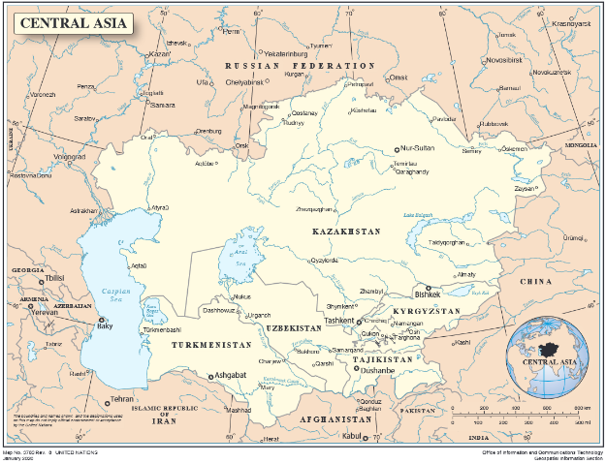

Annexe 2: Distribution Maps of the Selected Native Tree Species in Central Asia

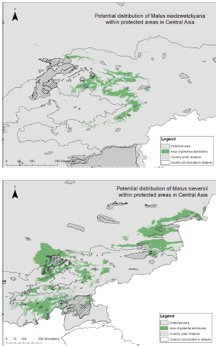
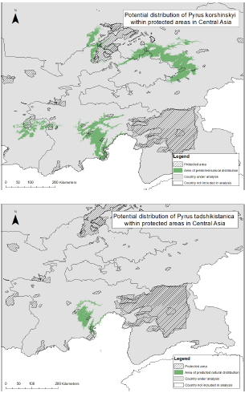
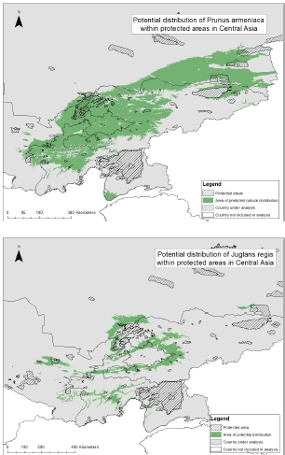

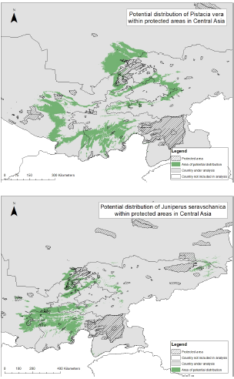

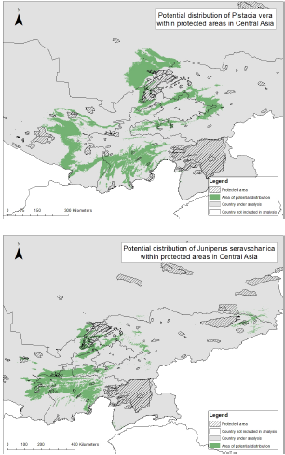

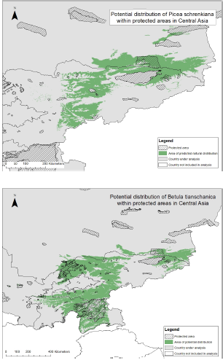

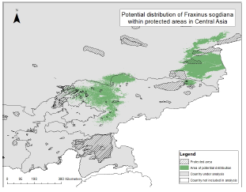

Annexe 3: Short-term Threat Maps of the Selected Native Tree Species in Central Asia

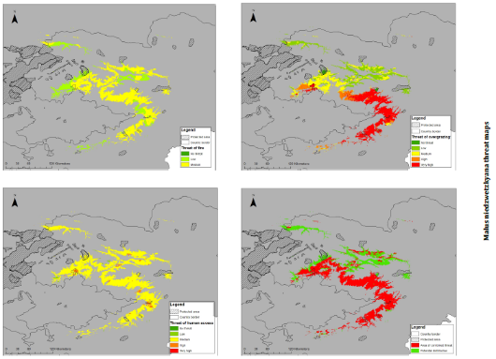
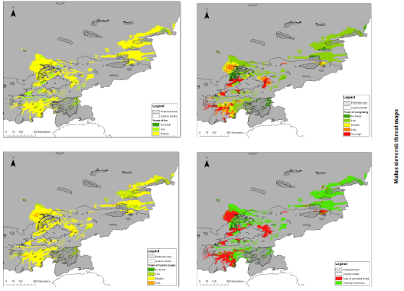
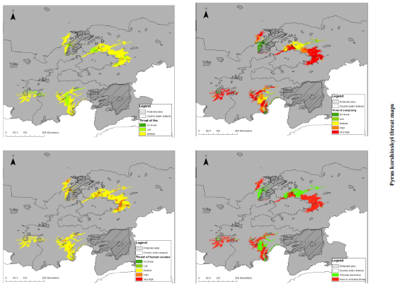

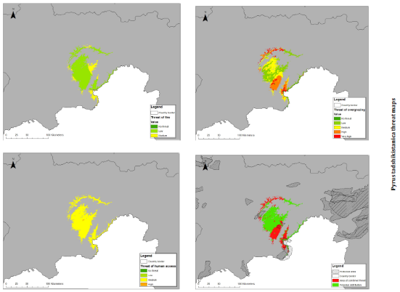

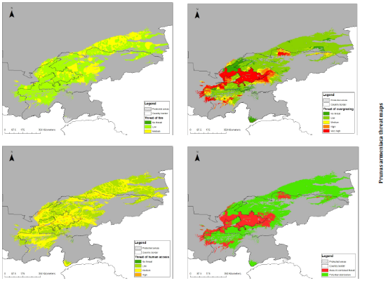

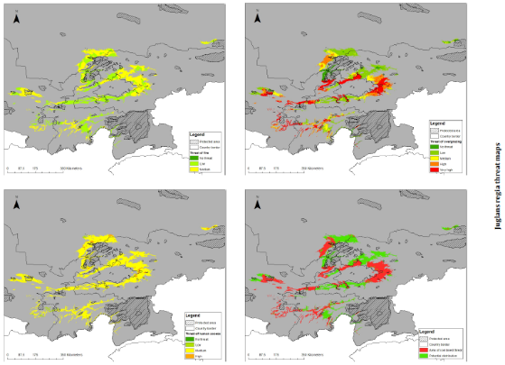

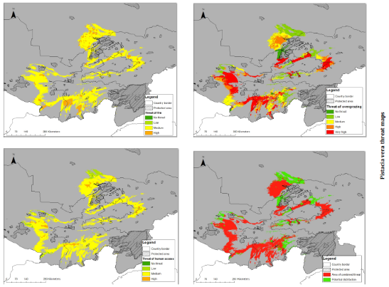

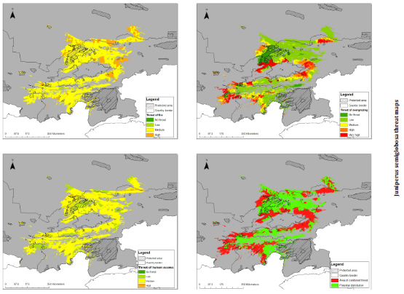

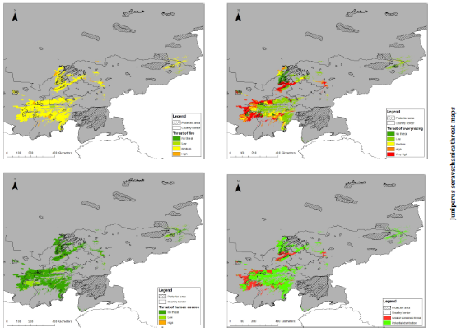

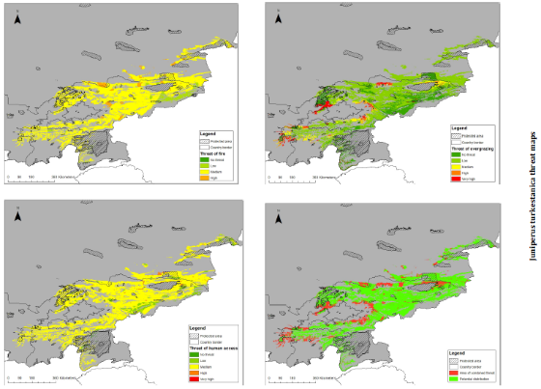

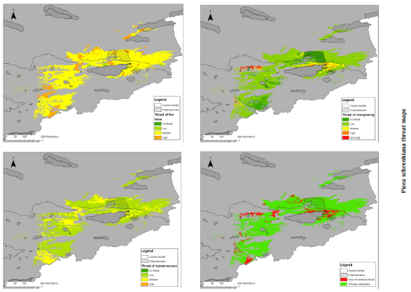

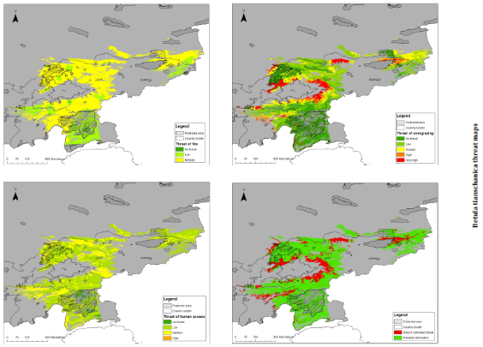

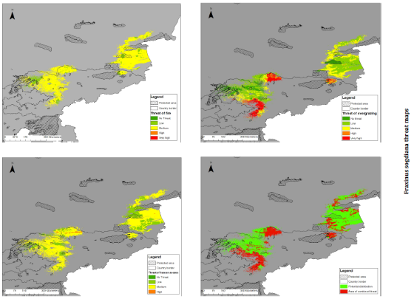

Annexe 4: Combined Threat Maps of the Selected Native Tree Species in Central Asia

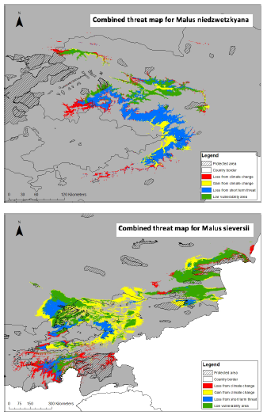
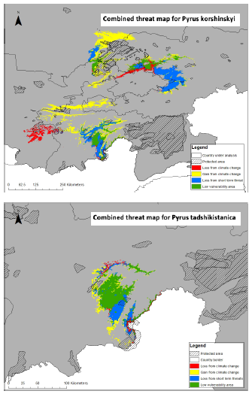
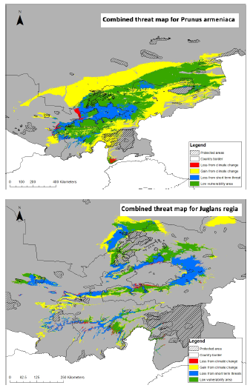
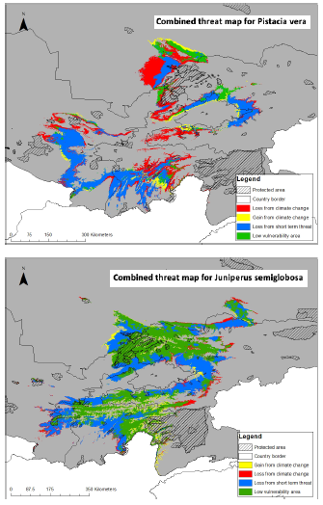
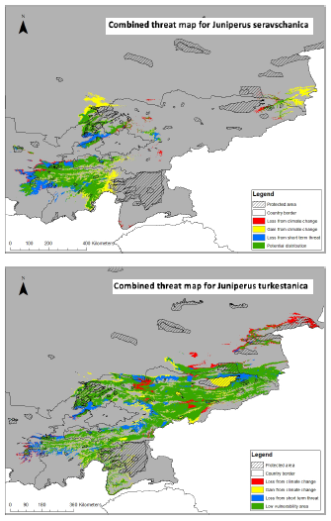
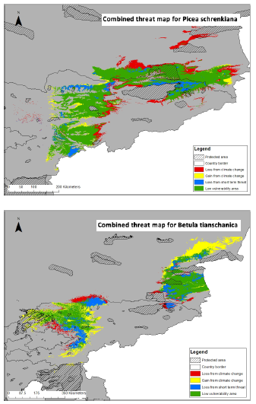
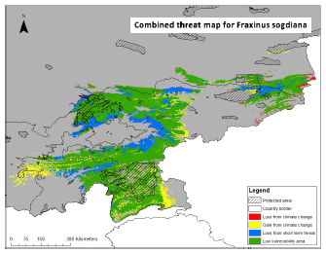

Annexe 5: Ecoregion Maps of the Selected Native Tree Species in Central Asia

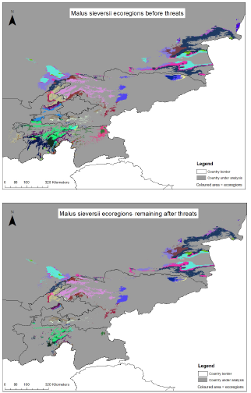
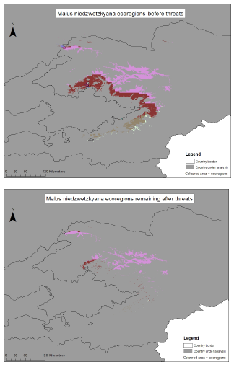
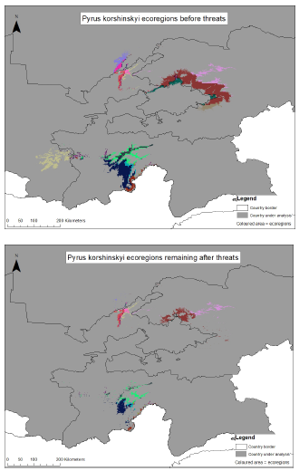
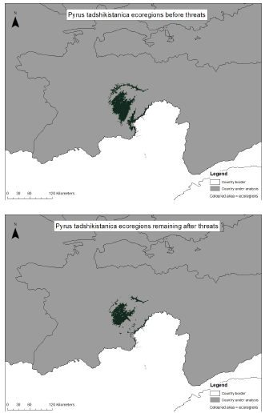
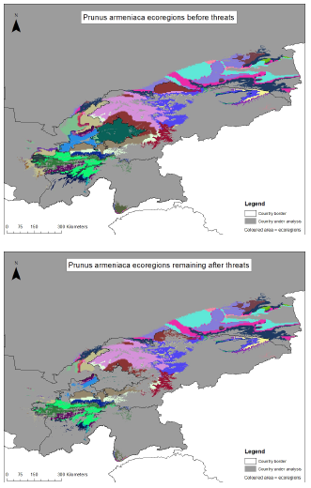
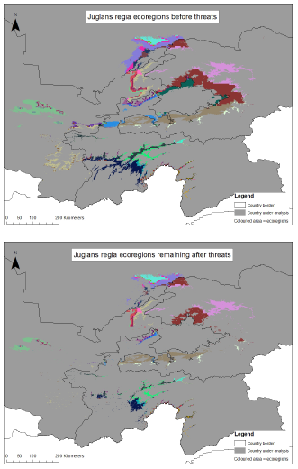
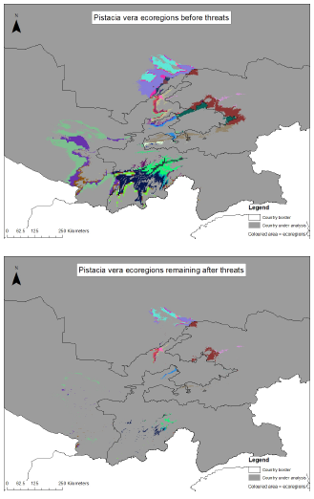
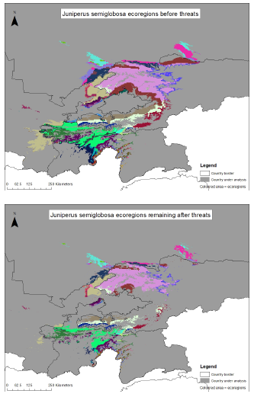
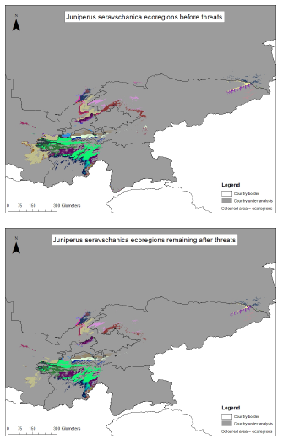
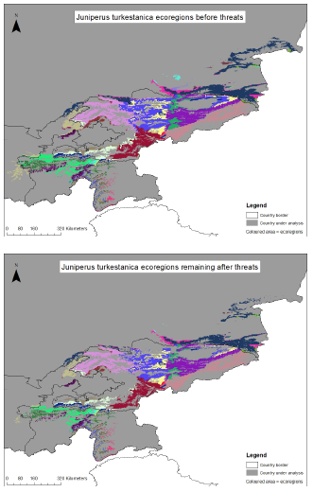
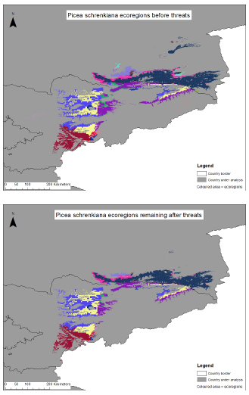
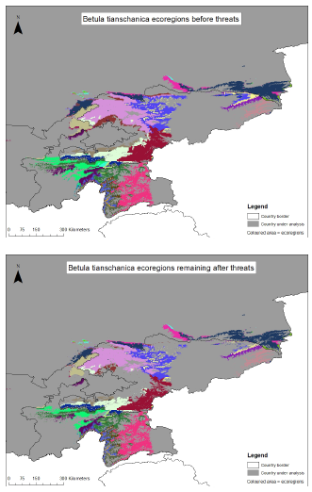
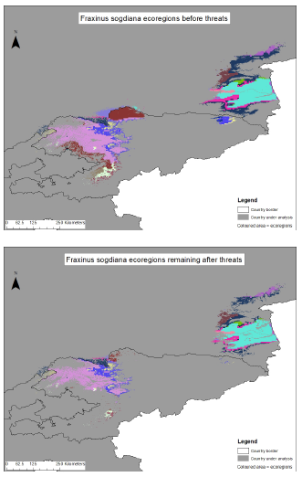

Annexe 6: Fundamentals for Selecting Sites for Establishing Propagation Sites and Nurseries

Sustainable forest management practices, rehabilitation/restoration techniques for degraded forests, production of ornamental seedlings and fruit tree seedlings require suitable quality planting materials. Produce these planting materials in well-structured, organized, established and managed nurseries.

A nursery is a managed site established to produce suitable quality planting materials grown under special conditions and care for planting for sustainable forest management practices, rehabilitation/restoration of degraded forests and horticulture.

Modern nurseries offer technology facilities, machinery, equipment, tools, and the best seed processing and seedling practices. Therefore, successful, standard, planned, sufficient and sustainable good quality seed processing and seedling production could be ensured throughout the year, resulting in a high survival rate of seedlings and success in SFM practices, reforestation and restoration/rehabilitation areas at the regional and national levels.

Nurseries play a critical role in global efforts to combat climate change, forest degradation, land degradation, desertification and support forest and landscape restoration programmes. Ensure this critical role by providing good quality seeds and seedlings for restoration/rehabilitation of degraded forests and other lands, supporting forest management practices, establishing new forest ecosystems, and supplying seedlings for fruit and nut trees, including medicinal and aromatic plants.

Nurseries can also serve as a seed bank and propagation site, provide storage for species, establish and maintain demo plots, seed orchards, stooling beds, and other sources of propagative material. In addition, nurseries serve as training centres, and educational programs can be implemented in nurseries, including extension services. Nurseries also provide an enabling environment for research activities to improve the seed harvesting, handling, processing and seedling production techniques and seedling quality. Moreover, nurseries play a crucial role in improving people's livelihoods by employing nursery workers (Haase and Davis, 2017). Moreover, nurseries also improve the livelihoods of local farmers. Improving the livelihoods is ensured by producing income-generating species, including fruit and nut trees and medicinal, aromatic, and ornamental species. Production of various types of seeds and seedlings in modern nurseries supports biodiversity conservation and expands biodiversity habitats. Seeds and seedlings produced in nurseries could establish shelterbelts around the agricultural areas to reduce the adverse effects of erosion, support crop production in food safety, and stabilize the soil loss through river and channel sides. Nurseries create an enabling environment for the employment of local people, especially women, to empower women participation in nursery activities, leading to the improvement of livelihood and creation of new jobs and increased opportunities for income generation. Good quality planting materials may lead to establishing a certification system to produce certified seeds and seedlings. Nurseries create an enabling environment for developing new green ideas from the local level to the global level through playing a role in urban and rural development, including supporting the sustainable use of all land-use types. Nurseries support the demand of future local, national and regional sustainable resource management projects. Nurseries also serve as a knowledge and information-sharing platform and demonstration site at the local, national and regional level by including neighbouring countries, seedling producers and farmers.

Nurseries improve communication on objectives and environmental, social and economic benefits of nurseries; support Central Asia participation in global initiatives and platforms and improve rural extension support (Bull et al., 2018; Strassburg et al., 2018; Stanturf et al., 2019).

Model nursery practices and various forestry activities in the field will raise awareness amongst policy, decision-makers, and local stakeholders to enhance the critical role of forest ecosystems and the forestry sector in Central Asia to conserve genetic biodiversity. The establishment of nurseries requires fundamental factors and conditions as well as adequate funding.

Development of nurseries starts from the site selection that consists of several criteria or technical planning considerations including, but not limited to the size of the catchment area, estimation of production needs, criteria for land selection (i.e., water, soil, electricity, local infrastructure), necessary space extend, machinery, equipment, tools and facilities, workforce availability, maintenance, and investment plan. Once the site is selected, including design, layout and components of a nursery, other detailed planning (physical establishment of nurseries from ground preparation to the construction of facilities) and management (business plan, nursery development programme, records, maintenance, marketing), including seedling production programme (from seed collection to transportation of seedlings to field sites) issues should be taken into consideration. Technical planning considerations to select possible areas for the development of nurseries are the type of the nursery, location (Site selection), space availability and size, climate, soil, water supply for irrigation and water quality, electricity, availability of labour, shelter and fencing, topography and aspect, seedling demand and production types, ownership, accessibility, telecommunication, transport, infrastructure and facilities and machinery, tools and equipment.

Type of the nursery

Nurseries can be developed either on a permanent or temporary basis. While permanent nurseries serve for more extended periods, temporary nurseries serve for a few seasons or years.

Location (Site selection)

Locate nurseries close to plantation sites or close to populated areas connected with main roads to reduce transportation costs of seedlings to field sites and the accommodation costs of nursery workers. Moreover, administrative and operational matters in the nursery require input, such as materials, equipment, tools, and food. In addition to that, carefully select the nursery location to avoid wind damage and flooding (Hall, 2003). Therefore, site selection would be the most critical technical planning consideration.

Space availability and size

The main factors that influence the space availability and size are the number of seedlings to be produced, the production types (production from seeds, grafts, bare-rooted cuttings or production in beds and containers, including the diameter of the containers) and water availability. In addition to that, plan the nursery site with additional space for facilities, storage areas, materials, manure (Dar, 2016). Generally, seedling production areas (seedling beds, greenhouse, replacement beds, material areas) and facilities (offices, buildings, parking lot) are the main two sections of a nursery. The share of these two sections can be changed based on the production capacity and demand.

Climate

Nursery sites should have good climatic and environmental conditions to support seedling production. Nursery sites should not be too wet or too dry. Meteorological data on precipitation and temperature provide sufficient data on proposed nursery sites to check the availability of rainfall and temperature (Liegel and Venator, 1987).

Soil

The nursery site should provide suitable soil and relevant planting materials such as sand for seedling production. Particle size, organic matter content, nutrient content, soil porosity, moisture content and pH are the main soil properties that provide information about the soil health and composition and this influence the quality of planting materials. Each property is interrelated and affects plant growth (Hall, 2003; Dar, 2016). The nursery site should provide a sufficient amount of good quality soil to prepare the container mixture and seedbeds. Otherwise, support the crop production by cattle manure, green manure, compost, or forest soil to improve nutrient content and structure. The container mixture may have sand to some extend if the soil is too heavy. In addition to organic soil to improve the nutrient content and local nursery soil, use clay soil for physical structure for water infiltration (Dar, 2016). The minimum depth of the soil should be 120 cm, and PH should be between 5 and 6 in nurseries for most of the tree species.

Water supply for irrigation and water quality

Nursery sites should have permanent water supply such as river, spring, pond, and well, piped water system for irrigation throughout the year and minimum slope or system for drainage. Store a minimum of three days water supply in relevant storage facilities (Hall, 2003). Water quality is another critical technical planning consideration. pH value should be between 5.5 and 7.

Electricity

Nurseries must have permanent power (electricity) supply to support seedling production and use of necessary machinery, tools and equipment throughout the year. In addition to the electricity network, generators in case of an electricity shortage should also support nurseries.

Availability of labour

Locate the nursery where an available workforce can be employed. Nursery activities require an intensive workforce and the interactions between the nursery and workforce availability affect the accommodation costs and other nursery costs.

Shelter and fencing

Protect nursery sites against wind and livestock with natural vegetation and manufactured structures.

Topography and aspect

Nursery areas should be flat, sheltered and must have a slight slope for drainage. Support the nursery area with a drainage system based on the site requirements (Hall, 2003). Aspect is another critical technical planning consideration. For example, sunlight in the afternoon can cause seedling damage on the south aspect during the summertime.

Seedling demand and production types

Seedling demand in terms of the number of seedlings and production types (bare rooted or container seedlings), restoration/rehabilitation programmes and other forestry and horticulture activities are essential factors for selecting nursery sites.

Ownership

Land ownership is an essential technical planning consideration. The owner of the land should be clear.

Accessibility

Nursery sites must be easily accessible throughout the year. Accessibility will allow the seedling transfer to the field sites and markets and allow customers to come to nurseries to buy seedlings.

Telecommunication

Nurseries must have good telecommunication channels such as telephone, internet, e-mail, radio, mobile phone for administrative, operational and marketing purposes.

Access and Transport

Nurseries must have good access roads to deliver planting materials to the required sites fast and ensure consumers' easy access to the nursery sites.

Infrastructure and facilities

Nurseries should have the infrastructure and various facilities for administrative and operational reasons and based on the planting material demand. Each nursery may have a water pool, material area, conifer replanting/transplantation area, bare-rooted seedling production area, container seedling production area, seed extraction area, seedling material area, deciduous replanting/transplantation area, greenhouse, manure area, machinery and equipment parking lot, storage room, worker resting facility and WC, seed storage room, administration facilities, sheltered working area and central and side roads.

Machinery, tools and equipment

Nurseries must be supported with a sufficient number of machinery, tools and equipment to conduct nursery operations. The list of machinery, tools and equipment may slightly change based on the nursery objectives. Inventory of all items must be kept in the records. Moreover, all relevant items should be ready once the nursery is physically established, and experienced staff must conduct periodic maintenance activities. The nursery must also have a storage area and parking lot for machinery, tools and equipment.

Annexe 7: Seed Transfer Zones and Nurseries Required in Central Asia

The previous section explained the fundamentals for selecting sites for establishing nurseries. However, some other factors are also available for consideration to determine the number of nurseries and their exact locations. For example, nurseries usually produce seeds and seedlings of different tree species. The nursery's location should match the habitat requirements of target tree species raised and planted in the field in the future. Additionally, geographical and climatic factors positively affect on landraces of different tree species. A nursery should allow the production of seeds and seedlings of different tree species for multipurpose forestry operations.

Moreover, the altitude difference between the nursery and a plantation site should be a maximum of 500-600 meters. In this case, the nursery should be at a lower altitude. It is also recommended that nurseries are close to plantation sites and consider the number of required seeds and seedlings for plantations. Moreover, the state of forests is another criterion to decide on the establishment of nurseries. If all forests are productive, there may be no need for nurseries.

Furthermore, seed transfer zones for each tree species influence the number of nurseries and their locations. It is necessary to separate the seed harvesting and plantation zones according to specific species and transfer seeds within these zones o ensure safe seed transfer. The main factors in determining the seed transfer zones (foremost and sub-zone) are the distribution of tree species, including phenotypes, varieties and landraces, annual average temperature and its course throughout the year, annual average precipitation and the distribution of precipitation according to the seasons, precipitation efficiency, vegetation periods and humidity conditions of the vegetation period. For example, avoid seed transfer between the main zones under any circumstances since habitats between the main zones are different. Aspect is another factor and carries out the seed transfer throughout the same aspect. Seed transfer should be at the same altitude. If this is impossible, the maximum elevation difference should be 150 m to higher altitudes or -200 m to lower altitudes between the seed and plantation sites. Do not transfer seeds from mountain zones to valley zones. The maximum horizontal distance in seed transfer on the same altitude should not exceed 100-150 km. In places with local climatic characteristics, seed transfer from a zone with the same local climatic conditions should be done. Finally, other factors in establishing nurseries could be the forestry organisation's land ownership and institutional structure.

A specific example is available in Turkey. The Forest Law (Article 60) and associated legislation authorize the General Directorate of Forestry (OGM) to establish nurseries across the country. The institutional structure of OGM is consist of central units and regional/local units. As of 2020, OGM has 28 regional forestry directorates and 263 local forestry directorates and 28 forest nursery directorates. Moreover, OGM developed distribution maps of forests and tree species based on the forest management plans and seed transfer zone maps for some selected tree species (i.e., pine, spruce, beech, cedar) (Please see Annexe 8 for seed transfer zone maps).

In detail, forests (productive, degraded, area, tree species, and possible forestry operations such as logging and plantation) are also defined in the forest management maps. These works allowed OGM to plan and implement plantation activities, tree species, required seeds and seedlings, and the required nurseries across the country. The analyses about the locations of the nurseries revealed that three primary factors influenced the locations of nurseries, namely, size and area coverage of regional forestry directorates, state of forests and seed transfer zones in Turkey. Although some regional forestry directorates have not established nurseries, some have established two in different locations because of the factors above. At least one nursery could be established for each regional forestry directorate on average to give an insight.

Various geographical formations such as peaks, high mountain plateaus, valleys, glaciers, steppes and desert plains characterize the landscape of Central Asia. Two of Asia’s major mountain ranges – the Pamirs in Tajikistan and the Tien Shan in Kyrgyzstan – make those countries the most mountainous in Central Asia (Figure 2). Overall, mountains cover 20% of the total area of Central Asia.

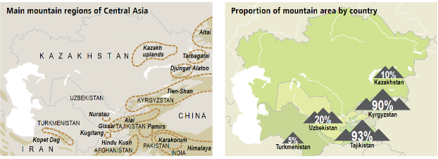

The decision on the establishment of new nurseries should focus on the distribution maps of native tree species in Central Asia and carefully consider the criteria mentioned above and factors such as state of forests, especially the degraded forests, land ownership, institutional structures of forestry organizations, seed transfer zones, conservation needs or certain native tree species.

Annexe 8: Seed Transfer Zone Maps of the Selected Tree Species in Turkey

Black pine (Atalay and Efe, 2010)

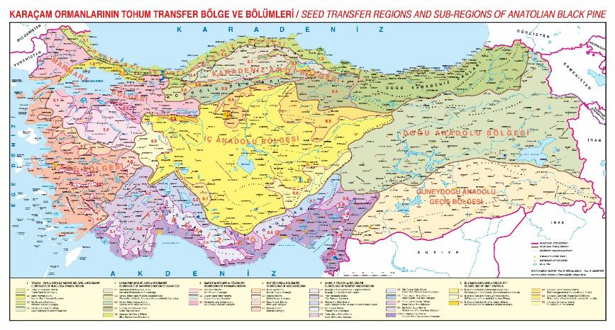

Beech (Atalay, 1992)

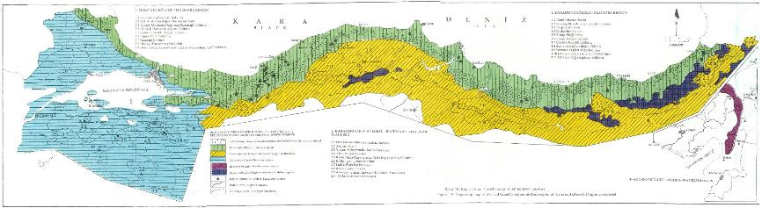

Spruce (Atalay, 1984)

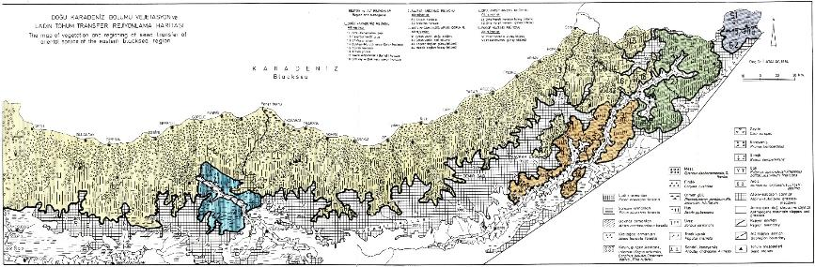

Turkish pine/ Calabrian pine (Atalay et al., 1998)

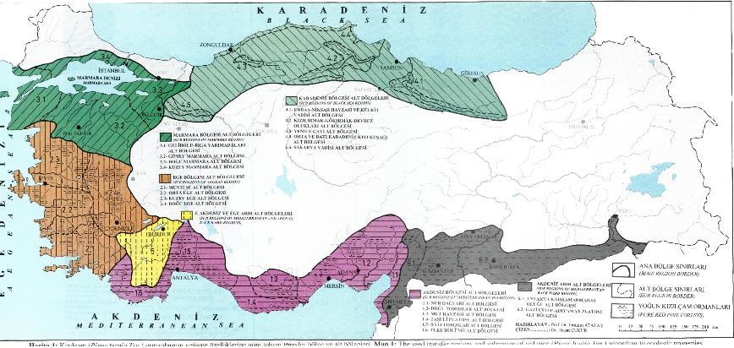

Cedar (Atalay, 1987)

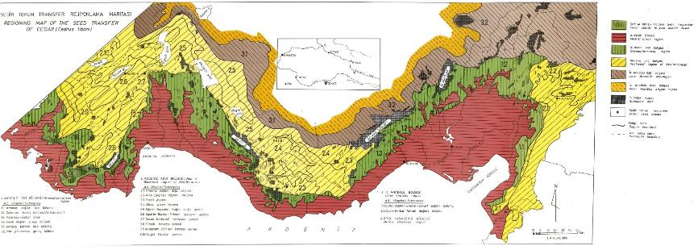

Scots pine/Scotch pine (Atalay and Efe, 2012)

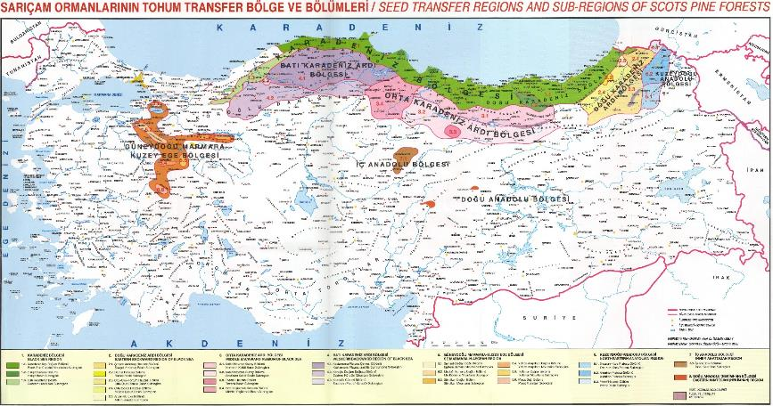

Annexe 9: Fruit and Cone Maturity and Other Characteristics of Native Tree Species

Tree Species |  | Maturity Time of the Cone/Fruit | Cone/Fruit Ripening Time (Months) | Seed Harvesting Period | Good Seed Year Recurrence (Year) | Seed Weight from 100kg Cone (kg)
Genus Name | English
Picea | Spruce | October-November | 12 | October-November | 2-4 | 1.5
Fraxinus | Ash | August-October | 12 | October-November | 2-3 | -
Betula | Birch | August-September | 12 | August-September | - | -
Juglans | Walnut | September-October | 12 | September-October | 2 | -
Juniperus | Juniper | September-November | 17-19 | October-March | 2(3) | -

Annexe 10: Seed Characteristics of Native Tree Species

Tree Species |  | 1000 Seed Weight | Moisture | Germination Rate | Germination Period | Seed Quantity in 1 kg Seed | Cold Storage |  |  | Germination Barrier | Actions to Remove Germination Barrier
Genus Name | English |  |  |  |  |  | Temperature | Period | Moisture
 |  | gr | % | % | Days | Number | ⁰C | Year | %
Picea | Spruce | 7.4 | 6-8 | 90 | 21 | 118000 | 4 | 5 | 6-8 | No | -
Fraxinus | Ash | 59 | - | 76 | 56 | 17000 | 4 | >3 | - | Yes | Cold, wet stratification for two months at 20⁰C and seven months at 3⁰C
Betula | Birch | 0.5-0.6 | 3 | 25 | 21 | 2000000 | -4-10 | 10 | 3 | No | -
Juglans | Walnut | 8000-12500 | 20-40 | 75 | 40 | 100 | 0 | 2 | - | Yes | Fall plantation or cold, wet stratification for 1-2 months in Spring
Juniperus | Juniper | 17-108.4 | - | 60-80 | - | 9200-58000 | - | 10 | - | Yes | 3-5 days soaking in 20% ash water, soak in 5000ppm citric acid for three days, Warm wet stratification for one month at 15-20⁰C, Warm wet stratification for one month at 10⁰C

Annexe 11: Glossary

ACCESSION A plant or seed sample, strain or population held in a gene bank or breeding programme for conservation and use.
ADAPTIVE GENETIC VARIATION Difference in genotype due to population adjustment to changes in the environment over generations. The adjustment is associated (at least in part) with genetic changes resulting from selection imposed by the changing environment.
BIOLOGICAL DIVERSITY The variety of life at genetic, species and ecosystem levels (FAO, 2019a),
BREEDING SYSTEM The system by which a species reproduces. Several natural systems in plants: (i) out-breeding (exogamy, crossbreeding) is a mating system in which mating is between individuals less closely related than average pairs chosen from the population at random. (ii) Inbreeding (endogamy, self-breeding) is the crossing of individuals that are more closely related genetically than individuals mating at random, especially when repeated for several successive generations. (iii) Clonal reproduction. A species may use one or more of these systems.
CLONAL ARCHIVE A clonal archive (or clone bank) is a collection of genetic individuals which are retained for: (i) the commercial production of propagules, (ii) implementing a breeding strategy, (iii) genetic conservation. The individuals within the clone bank may be raised from seeds but more commonly are grafts whereby the stem, or scion, from the genotype selected in a genetic test, have been grafted onto a juvenile rootstock in the nursery before planting out in the clone bank. It is common for there to be multiple copies (ramets) of each clone, and these are usually planted adjacent to each other within the clone bank.
CONSERVATION (OF A RESOURCE) The actions and policies that assure its continued availability and existence.
CONSERVATION (OF GENETIC RESOURCES) The management of human use of genetic resources may yield the most significant sustainable benefit to present generations while maintaining their potential to meet the needs and aspirations of future generations.
CRYOPRESERVATION The preservation or storage in frigid temperatures, usually in liquid nitrogen. It is a form of conservation for some seeds and tissues.
DORMANCY A period in the life of an animal or plant during which growth slows or completely ceases.
ECOSYSTEM is a dynamic complex of plants, animal and micro-organisms, communities, and non-living environments interacting as a functional unit.
EFFECTIVE POPULATION SIZE The number of individuals in an ideal population with the same genetic drift level and inbreeding as the population from which it is drawn.
EX SITU (CONSERVATION) is the conservation of components of biological diversity outside their natural habitats.
FOREST BIOLOGICAL DIVERSITY contains all-life forms and their ecological roles found in forestlands at ecosystem, landscape, species, population and genetic levels (FAO and UNEP, 2020).
FOREST GENETIC RESOURCES are the heritable materials maintained within and among tree and other woody plant species that are of actual or potential economic, environmental, scientific or societal value (FAO, 2014a).
GENE In an organism's genome, a sequence of nucleotides (DNA sequence) to which a specific function can be assigned.
GENEBANKS A facility where germplasm is stored in the form of seeds, pollen or in vitro culture, or the case of field gene banks, as plants growing in the field.
GENE FLOW Exchange of genes between populations owing to the dispersal of gametes or zygotes.
GENE POOL The total sum of the genetic material of an interbreeding population.
GENE(TIC) CONSERVATION All actions aimed at ensuring the continued existence, evolution and availability of genetic resources.
GENETIC DIVERSITY The total genetic differences between species and within species.
GENETIC DRIFT Change in allele frequency from one generation to another within a population due to the sampling of finite numbers of genes that are inevitable in all finite-sized populations. The smaller the population, the greater the genetic drift, with the result, that some alleles are lost, and genetic diversity is reduced.
GENETIC EROSION Gradual loss of genetic diversity.
GENETIC RESOURCES The economic, scientific or societal value of the heritable materials contained within and among species.
GENETIC VARIATION Variation due to the contribution of segregating genes and gene interactions.
GENOTYPE The total of the genetic information contained in an organism or the genetic constitution of an organism concerning one or a few gene loci under consideration.
GERMPLASM The total genetic variability available to a particular population of organisms, represented by the pool of germ cells (sex cells, the sperm or egg) or plant seeds. Also used to describe the plants, seeds, or other parts useful in plant breeding, research, and conservation efforts, when they are maintained to study, manage, or use the genetic information they possess (same as genetic resources).
INBREEDING Mating between individuals with one or more ancestors in common, the extreme condition is self-fertilization, which occurs naturally in many plants.
IN SITU (CONSERVATION) The conservation of ecosystems and natural habitats and the maintenance and recovery of viable populations of species in their natural surroundings and, in the case of domesticated or cultivated species, in the surroundings where they have developed their distinctive properties.
INTERMEDIATE SEED Seed can be desiccated, although not to such low levels as orthodox seed, and is often sensitive to chilling.
INTRASPECIFIC GENETIC VARIATION Genetic variation within a species.
IN VITRO ‘In a glass’. This term refers to an experiment performed in an artificial environment such as a test tube or culture media.
LANDRACE An early, cultivated form of a crop species evolved from a wild population and generally composed of a heterogeneous mixture of genotypes.
ORTHODOX SEED Seed which is desiccation-tolerant.
PARENT TREES A pollen donor and/or ovules producer.
PHENOTYPE The observable characteristics of an individual resulting from the interaction between genotype and environment in which development occurs.
POPULATION A group of individuals of the same species occupying a defined area and genetically isolated to some degree from other similar groups.
PROVENANCE The geographical and/or genetic origin of an individual.
RECALCITRANT SEED Seed is desiccation-sensitive, with a short hydrated life span in storage typically ranging from a few days to several months. Recalcitrant seed behaviour is most prevalent in tree species from tropical, humid zones with larger seeds (>3-5 g).
ULTRA-DRY STORAGE A ‘low-input alternative to the conventional cold storage of seed. Seeds are stored in airtight containers at room temperature after processing to adjust their moisture levels. This is not as effective as low-temperature methods for seeds that can withstand low temperatures. It is worth considering when maximum longevity is not essential, and refrigeration facilities are not readily available.
VEGETATIVE REPRODUCTION In plants, the formation of a new individual from a group of cells without producing an embryo or seed. Vegetative, somatic, non-sexual reproduction of a plant without fertilization.

Annexe 12: References

Aravanopoulos, F.A. 2016. Conservation and Monitoring of Tree Genetic Resources in Temperate Forests. Current Forestry Reports. Springer International Publishing, pp.119–129. doi: 10.1007/s40725-016-0038-8.
Atalay, İ. 1984. Regioning of the Seed Transfer of Oriental Spruce (Picea orientalis L.) in Turkey. Forest Tree Seeds and Tree Breeding Research Institute Directorate. Volume 2. 66pp. Ankara.
Atalay, İ. 1987. General Ecological Properties of Natural Occurrence Areas of Cedar (Cedrus libani A. Rich) Forests and Regioning of Seed Transfer of Cedar in Turkey. General Directorate of Forestry. Volume: 663. Serie: 61. 184pp. Ankara.
Atalay, İ. 1992. The Ecology of Beech (Fagus orientalis Lipsky) Forests and Their Regioning in Terms of Seed Transfer. Forest Tree Seeds and Tree Breeding Research Institute Directorate. 290pp. Ankara.
Atalay, İ., Sezer, L.İ., Çukur, H. 1998. The Ecological Properties of Red Pine (Pinus brutia Ten.) Forests and Their Dividing into Regions in Terms of Seed Transfer. Forest Tree Seeds and Tree Breeding Research Institute Directorate. Volume 6. 108pp. İzmir.
Atalay, İ., Efe, R. 2010. Ecology of the Anatolian Black Pine [Pinus nigra Arnold subsp. pallasiana (Lamb.) Holmboe] and Its Dividing into Regions in Terms of Seed Transfer. Forest Tree Seeds and Tree Breeding Research Institute Directorate. Volume 37. Serie: 4. 240pp. Ankara.
Atalay, İ., Efe, R. 2012. Ecology of Scots Pine (Pinus sylvestris L. var. sylvestris) Forests and Their Dividing into Regions in Terms of Seed Transfer in Anatolia (Turkey). Forest Tree Seeds and Tree Breeding Research Institute Directorate. Volume 45. Serie: 5. 320pp. Ankara.
Barazani, O., Atayev, A., Yakubov, B., Kostiukovsky, V., Popov, K., & Golan-Goldhirsh, A. 2003. Genetic variability in Turkmen populations of Pistacia vera L. Genetic Resources and Crop Evolution, 50(4), 383-389.
Barner, H. 1975. Identification of sources for procurement of reproductive materials. Pp.
42–64 in Report on FAG/DANIDA Training Course on Forest Seed Collection and
Handling, Vol. 2. FAO of the United Nations, Rome, Italy.
Barton, D.W. 1975. Preserving genetic diversity. New York Food Life Sci. 9:18.
Boshier, D. 2011. Species conservation strategies. Introductory notes for teachers. In: Forest Genetic Resources Training Guide. Edited by Boshier D, Bozzano M, Loo J, Rudebjer P. Bioversity International, Rome, Italy.
Broadhurst, L., Waters, C., Coates, D. 2017. Native seed for restoration: a discussion of key issues using examples from the flora of southern Australia. Rangeland Journal 39:487–498.
Brooks, H.J., Barton, D.W. 1977. A plan for national fruit and nut germplasm repositories. HortScience 12:298–300.
Brown, A.D.H. and Hardner, C.M. 2000. Sampling the gene pools of forest tree species for
ex situ conservation. Pp. 185–196 in Forest Conservation Genetics—Principles and
Practice (A. Young, D. Boshier and T. Boyle, eds.). CSIRO Publishing, Collingwood,
Australia and CABI Publishing, Wallingford, UK.
Bull, G., Boedhihartono, A., Bueno, G., Cashore, B., Elliott, C., Langston, J., Riggs, R., and Sayer, J. 2018. Global forest discourses must connect with local forest realities; International Forestry Review, Vol. 20; DO - 10.1505/146554818823767573.
Cantarello, E., Lovegrove, A., Orozumbekov, A., Birch, J., Brouwers, N., & Newton, A.C. 2014. Human Impacts on Forest Biodiversity in Protected Walnut-Fruit Forests in Kyrgyzstan, Journal of Sustainable Forestry, 33:5, 454-481, DOI:10.1080/10549811.2014.901918.
CBD. 2011. Nagoya Protocol on the Access to Genetic Resources and the Fair and Equitable Sharing of Benefits Arising from their Utilization. [Cited on 20 May 2021]. https://www.cbd.int/abs/doc/protocol/nagoya-protocol-en.pdf
CBD. 2021. Aichi Biodiversity Targets. In: Convention on Biodiversity [online]. Montreal, Canada. [Cited 13 May 2021]. https://www.cbd.int/sp/targets/
Chekalin S.V., Nurmuratuly, T.N. 2010. National methodology for the assessment and conservation of agrobiodiversity of mountain fruit forests in Kazakhstan.
CGIAR. 2015. Fruit trees for sweet futures in Central Asia. 2014 ‒ 2015 HIGHLIGHTS. 3p. [Cited on 4 June 2021]. https://wle.cgiar.org/sites/default/files/documents/Fruit%20trees%20in%20Central%20Asia_WLE.pdf
Conway, W. 1988. Can technology aid species preservation? Pp. 263–268 in Biodiversity (E.O. Wilson, ed.). National Academy Press, Washington, DC, USA.
Cooley, A. 2014. Central Asia. Handbook of Governance and Security. pp. 148–163. doi: 10.4337/9781781953174.00018.
Dar, B. 2016. Training Manual: Awareness Creation, Nursery Establishment, Plantation Development and Agroforestry Management Practices. Part of the NABU-project: "Community-based Climate Adaptation and Biodiversity Conservation in the model area of Lake Tana Biosphere Reserve, Ethiopia" 67p, Ethiopia.
DeVitis, M., Fiegener, R., Dickie, J., Trivedi, C., Choi, J., & Hay, F. 2020. Seed storage: maintaining seed viability and vigor. Restoration Ecology 28: S248–S254
Eastwood, A., Lazkov, G., Newton, A. 2009. The Red List of trees of Central Asia. Cambridge: Fauna &Flora International. 27p. [Cited on 4 June 2021]. https://portals.iucn.org/library/sites/library/files/documents/RL-2009-006.pdf
Engels, J.M.M., Wood, D. 1999. Conservation of agrobiodiversity. Pp. 355–386 in Agrobiodiversity: Characterization, Utilization and Management (D. Wood and J.M. Lenné eds.). CABI Publishing, Wallingford, UK.
ENSCONET. 2009. Seed collecting manual for wild species. [Cited on 22 June 2021]. https://www.luomus.fi/sites/default/files/files/collecting_protocol_english.pdf
FAO. 1985. A guide to forest seed handling with special reference to the tropics. FAO FORESTRY PAPER 20/2. [Cited on 17 June 2021]. http://www.fao.org/3/AD232E/AD232E00.htm#TOC
FAO. 1993. Collection, Storage, and Treatment of Tree Seeds: A Handbook for Small Farm Tree Planters. Regional Wood Energy Development Programme in Asia. [Cited on 11 June 2021]. http://www.fao.org/3/ad226e/AD226E00.htm#TOC
FAO. 2009. The International Treaty on Plant Genetic Resources for Food and Agriculture. [Cited 20 May 2021]. http://www.fao.org/3/i0510e/i0510e.pdf
FAO. 2010. FAO Strategy for Forests and Forestry. Rome. 9p. [Cited 13 May 2021]. http://www.fao.org/3/al043e/al043e00.pdf
FAO. 2014a. The State of the World’s Forest Genetic Resources. Commission on Genetic Resources for Food and Agriculture. Rome. 276p. [Cited on 2 June 2021]. http://www.fao.org/3/i3825e/i3825e.pdf
FAO. 2014b. The State of the World’s Forest Genetic Resources Synthetic Account. Commission on Genetic Resources for Food and Agriculture. 14p. [Cited on 28 May 2021]. http://www.fao.org/3/i3827e/i3827e.pdf
FAO. 2014c. Global Plan of Action for the Conservation, Sustainable Use and Development of Forest Genetic Resources. Commission on Genetic Resources for Food and Agriculture. Rome. 31p. [Cited 13 May 2021]. http://www.fao.org/3/i3849e/i3849e.pdf
FAO. 2015. Coping with climate change – the roles of genetic resources for food and agriculture. 110p. Rome. [Cited on 23 May 2021]. http://www.fao.org/3/i3866e/I3866E.pdf
FAO. 2019a. The State of the World’s Biodiversity for Food and Agriculture. J. Bélanger & D. Pilling (eds.). FAO Commission on Genetic Resources for Food and Agriculture Assessments. Rome. 572 pp. [Cited on 20 May 2021]. http://www.fao.org/3/CA3129EN/CA3129EN.pdf
FAO. 2019b. Voluntary Guidelines for the Conservation and Sustainable Use of Farmers’ Varieties/Landraces. Rome. 135p. [Cited on 24 May 2021]. http://www.fao.org/3/ca5601en/ca5601en.pdf
FAO. 2020a. Global Forest Resources Assessment 2020 – Key findings. Rome. [Cited on 9 June 2021]. https://doi.org/10.4060/ca875
FAO. 2020b. FAO Strategy on Mainstreaming Biodiversity across Agricultural Sectors. Rome. [Cited 18 May 2021]. https://doi.org/10.4060/ca7722en
FAO. 2020c. Action Plan for the Implementation of FAO’s Strategy on Mainstreaming Biodiversity across Agricultural Sectors. Committee on Forestry. 31p. [Cited 18 May 2021]. http://www.fao.org/3/nd535en/nd535en.pdf
FAO. 2020d. People, forests and trees in West and Central Asia. Outlook for 2020. 136p. [Cited on 3 June 2021]. http://www.fao.org/3/a0981e/a0981e00.pdf
FAO. 2021a. Sustainable Forest Management Toolbox. [Cited on 11 June 2021]. http://www.fao.org/sustainable-forest-management/toolbox/modules/forest-reproductive-material/
FAO. 2021b. Sustainable Forest Management Toolbox. [Cited on 11 June 2021]. http://www.fao.org/sustainable-forest-management/toolbox/modules/forest-genetic-resources/
FAO, DFSC, IPGRI. 2001. Forest genetic resources conservation and management. Vol. 2: In managed natural forests and protected areas (in situ). International Plant Genetic Resources Institute, Rome, Italy.
FAO, FLD, IPGRI. 2004a. Forest genetic resources conservation and management. Vol. 1: Overview, concepts and some systematic approaches. International Plant Genetic Resources Institute, Rome, Italy.
FAO, FLD, IPGRI. 2004b. Forest genetic resources conservation and management. Vol. 3: In plantations and genebanks (ex situ). International Plant Genetic Resources Institute, Rome, Italy.
FAO & UNEP. 2020. The State of the World’s Forests 2020. Forests, biodiversity and people. Rome. 188p. (Also available at https://doi.org/10.4060/ca8642en)
FloraBank. 1999a. Guideline 6: Native Seed Collection Methods. 11p.
FloraBank. 1999b. Guideline 5: Seed Collection from Woody Plants for Local Revegetation. 11p.
Forsline, P.L., McFerson, J.R., Lamboy, W.F. 1996. Optimizing bud harvest time and duration of temporary cold storage for cryopreservation of dormant apple buds. HortScience 31:646 (Abstr. 473).
Forsline, P.L., McFerson, J.R., Lamboy, W.F., & Towill, L.E. 1999. Development of base and active collections of Malus germplasm with cryopreserved dormant buds. EUCARPIA Fruit Breeding Section Meeting, Oxford, England, September 1–6, 1996. Acta Hort. 484:75–78.
Forsline, P.L., Aldwinckle, H.S., Dickson, E.E., Luby, J.J., & Hokanson, S.C. 2003. Collection, maintenance, characterization, and utilization of wild apples of Central Asia. Horticultural Reviews-Westport then New York, 29, 1-62.
Gaisberger, H., Loo, J. 2017. Fruit tree genetic diversity in Central Asia: A spatial threat analysis. Rome. Biodiversity International. 2p.
Gaisberger, H., Kindt, R., Loo, J., Schmidt, M., Bognounou, F., Da, S.S., et al. 2017. Spatially explicit multi-threat assessment of food tree species in Burkina Faso: A fine-scale approach. PLoS ONE 12(9): e0184457. https://doi.org/10.1371/journal.pone.0184457.
Gaisberger, H., Legay, S., Andre, C., Loo, J., Aaliev, S., Bobokalonov, F., Muhsimov, N., Kettle, C.J., Vinceti, B. 2020. Diversity under threat: Connecting genetic diversity and threat mapping to set conservation priorities for Juglans regia L. populations in Central Asia. Frontiers in Ecology and Evolution 8:171. ISSN: 2296-701X
Gallacher, C. 2020. Identifying priority areas for the conservation of the intraspecific variation of native tree species in Central Asia. Faculty of Environment and Natural Resources, Albert-Ludwig-University Freiburg (Master of Science thesis)
GoKAZ. 2014. The fifth national report on progress and implementation of the Convention on Biological Diversity of Kazakhstan. 140p. [Cited on 29 May 2021]. https://www.cbd.int/doc/world/kz/kz-nr-05-en.pdf
GoKYR. 2016. The Fifth National Report on Conservation of Biodiversity of the Kyrgyz Republic. 74p. [Cited on 29 May 2021]. https://www.cbd.int/doc/world/kg/kg-nr-05-en.pdf
GoTAJ. 2014. The Fifth National Report on Preservation of Biodiversity of the Republic of Tajikistan. 148p. [Cited on 29 May 2021]. https://www.cbd.int/doc/world/tj/tj-nr-05-en.pdf
GoTRY. 1995. Pistachio Growing Technique. Pistachio Research Institute Directorate. [Cited on 24 June 2021]. https://arastirma.tarimorman.gov.tr/afistik/Belgeler/Taranan%20yay%C4%B1nlar/Antepf%C4%B1st%C4%B1%C4%9F%C4%B1%20Yeti%C5%9Ftirme%20Tekni%C4%9Fi%20001.pdf
GoTRY. 2001. Pistachio Growing Technique. Pistachio Research Institute Directorate. [Cited on 24 June 2021]. https://arastirma.tarimorman.gov.tr/afistik/Belgeler/Taranan%20yay%C4%B1nlar/antepf%C4%B1st%C4%B1%C4%9F%C4%B1%20yeti%C5%9Ftiricili%C4%9Fi%20yay%C4%B1n%2013%20001.pdf
GoTRY. 2003. Determining the harvest time of some pistachio varieties and investigating the applicability of machine harvesting. (Final Report). Pistachio Research Institute Directorate. [Cited on 24 June 2021]. https://arastirma.tarimorman.gov.tr/afistik/Belgeler/Taranan%20yay%C4%B1nlar/yay%C4%B1n%20no16%20001.pdf
GoTUR. 2015. The Fifth National Report on progress and implementation of the Convention on Biological Diversity of Turkmenistan. 61p. [Cited on 29 May 2021]. https://www.cbd.int/doc/world/tm/tm-nr-05-ru.pdf
GoUZB. 2015. The Fifth National Report on Conservation of Biodiversity of the Republic of Uzbekistan. 56p. [Cited on 29 May 2021]. https://www.cbd.int/doc/world/uz/uz-nr-05-en.pdf
Haase, D.L., Davis, A.S. 2017. Developing and supporting quality nursery facilities and staff are necessary to meet global forest and landscape restoration needs. Reforesta 4:69-93. DOI: https://dx.doi.org/10.21750/REFOR.4.06.45.
Hall, K.C. 2003. Manual on Nursery Practices. Forestry Department, Ministry of Agriculture, Jamaica, 70p.
IBPGR. 1985. Long-term seed storage of major temperate fruits. Rome.
IPCC. 2007a. Climate Change 2007: The Physical Science Basis. Contribution of Working Group I to the Fourth Assessment Report of the Intergovernmental Panel on Climate Change [Solomon, S., D. Qin, M. Manning, Z. Chen, M. Marquis, K.B. Averyt, M. Tignor and H.L. Miller (eds.)]. Cambridge University Press, Cambridge, United Kingdom and New York, NY, USA, 996 pp.
IPCC. 2007b. Climate Change 2007: Impacts, Adaptation and Vulnerability. Contribution of Working Group II to the Fourth Assessment Report of the Intergovernmental Panel on Climate Change, M.L. Parry, O.F. Canziani, J.P. Palutikof, P.J. van der Linden and C.E.Hanson, Eds., Cambridge University Press, Cambridge, UK, 976pp.
Kemp, R.H. 1975. International seed collecting expeditions. In Report on FAO/DANIDA Training Course on Forest Seed Collection and Handling, Vol. II. FAO Rome.
Lamboy, W.F., Yu, J., Forsline, P.L., & Weeden, N.F. 1996. Partitioning of allozyme diversity in wild populations of Malus sieversii L. and implications for germplasm collection. J. Am. Soc. Hort. Sci. 121:982–987.
Lapeña, I., Turdieva, M., López Noriega, I. & Ayad, W.G. 2014. Conservation of fruit tree diversity in Central Asia: Policy options and challenge. Biodiversity International. [Cited on 30 June 2021]. https://www.bioversityinternational.org/fileadmin/_migrated/uploads/tx_news/Conservation_of_fruit_tree_diversity_in_Central_Asia_1734.pdf
Liegel, L.H., Venator, C.R. 1987. A Technical Guide for Forest Nursery Management in Caribbean and Latin America. United States Department of Agriculture, Forest Service, Southern Forest Experiment Station, General Technical Report SO-67, 156p, Louisiana.
Matsui, K. 2019. Wood resources management: A case study of the Aral region, Kazakhstan. Department of Global Environmental Studies, Department of Land Ecosystem Management, (Dissertation)
Maxted, N., Ford-Lloyd, B.V., Hawkes, J.G. 1997. Complementary conservation strategies. Pp. 15–39 in Plant Genetic Conservation: The In situ Approach. (N. Maxted, B.V. Ford-Lloyd and J.G. Hawkes, eds.). Chapman & Hall, London, UK.
Miravalova, G., Gill, D., Boboev, M. & Sabzalieva, R. 2020. Мalus sieversii – wild apple: species status review and action plan for its conservation in Childukhtaron and Dashtijum reserves, Tajikistan.
Netchaeva, N.T., Vasilevskaya, V.K. and Antonova, K.G. 1973. Life Forms of Plants of Karakum Desert, pp. 241. Nauka, Moscow (In Russian).
Nevill, P.G., Cross, A.T., Dixon, K.W. 2018. Ethical seed sourcing is a key issue in meeting global restoration targets. Current Biology 28: R1378–R1379.
OECD. 1974. OECD scheme for the control of forest reproductive material moving in international trade. Paris.
OGM. 2019. Forestry Statistics - 2019. General Directorate of Forestry, Ankara, Turkey.
Parra-Quijano, M., Iriondo, J.M., & Torres, E. 2012. Ecogeographical land characterization maps as a tool for assessing plant adaptation and their implications in agrobiodiversity studies. Genetic Resources and Crop Evolution, 59(2), 205-217.
Pedrini, S., Dixon, K.W. 2020. International principles and standards for native seeds in ecological restoration. Restoration Ecology 28: S285–S302.
Pedrini, S., Gibson-Roy, P., Trivedi, C., Gálvez-Ramírez, C., Hardwick, K., Shaw, N., Frischie, S., Laverack, G., & Dixon, K. 2020. Collection and production of native seeds for ecological restoration. Restoration Ecology Vol. 28, No. S3, pp. S228–S238.
Pyankov, V.I., Black Jr., CC., Artyusheva, E.G., Voznesenskaya, E.V., Ku, M.S.B., & Edwards, G.E. 1999. Features of Photosynthesis in Haloxylon species of Chenopodiaceae that are Dominant Plants in Central Asian Deserts. Plant Cell Physiol. 40(2): 125-134 (1999).
Rachkovskaya, E.J., Volkova, E.A. & Khramtsov, V.N. 2003. Botanical Geography of Kazakhstan and Middle Asia. Sanct-Petersburg, NAUKA Republic of Armenia (2014).
REC. 2004. Central Asia Mountain Ecosystems. Seminar on the Role of Ecosystems as Water Supplier. Geneva, 13-14 December 2004. [Cited on 23 June 2021]. https://unece.org/fileadmin/DAM/env/water/meetings/ecosystem/Discpapers/CAmountainecosystem_carec.pdf
Robbins, A.M.J. and Shrestha, N.B. 2004. Guidelines for Tree Seed Collection. NR Study-Note F120b. Based on text and graphics in: Tree Seed Handling: A manual for field staff in Nepal. Field Document No. 11 HMG/EEC/ODA National Tree Seed Project HMG/UNDP/FAO Community Forestry Development Project.
Sokolov, S.Y., Svyazeva, O.A., and Kublii, V.A. 1977. A reals of Trees and Shrubs of the USSR. Vol. 2. pp. 142. Plus pp. 49. Maps, Nauka, Leningrad (In Russian).
Soltani, A. 2011. Seed germination response of Haloxylon persicum (Chenopodiaceae) to different hydrothermal conditions and sand burial depths. Caspian J. Env. Sci. 2011, Vol. 9 No.2 pp. 211-221.
Stanturf, J., Kleine, M., Mansourian, S., Parrotta, J., Madsen, P., Kant, P., Burns, J., and Bolte, A. 2019. Implementing forest landscape restoration under the Bonn Challenge: a systematic approach; Annals of Forest Science; Vol. 76; DO - 10.1007/s13595-019-0833-z.
Strassburg, B., Beyer, H., Crouzeilles, R., and Loyola, R. 2018. Strategic approaches to restoring ecosystems can triple conservation gains and halve costs; Nature Ecology & Evolution; Vol. 1; DO - 10.1038/s41559-018-0743-8.
Stein, W.I., Slabaugh, P.E., Plummer, A.P. 1974. Harvesting, processing and storage of fruits and seeds. In Seeds of Woody Plants in the United States, Agriculture Handbook No. 450. For. Service, USDA, Washington D.C.
Thevs, N. 2018. Forest Landscape Restoration in the Caucasus and Central Asia. Background study for the Ministerial Roundtable on Forest Landscape Restoration and the Bonn Challenge in the Caucasus and Central Asia (21-22 June 2018, Astana, Kazakhstan). Geneva Timber and Forest Discussion Paper 72. ECE/TIM/DP/72 Forestry and Timber Section, Geneva, Switzerland.
Topak, M. 1990. Ormancılıkta Tohum, Meyve ve Kozalak Toplama Esas ve Usulleri. General Directorate of Forestry Forest Tree Seeds and Tree Breeding Research Institute Directorate. Volume: 4. 51pp. Ankara.
UN. 1992. Convention of Biological Diversity. 28p. [Cited 13 May 2021]. https://www.cbd.int/doc/legal/cbd-en.pdf
USDA. 2000. ARS National Genetic Resources Program. Germplasm Resources Information Network (GRIN). [Online Database] National Germplasm Resources Laboratory, Beltsville, MD.
Way, M.J. 2003. Collecting seed from non-domesticated plants for long-term conservation. In: Smith RD, Dickie JB, Linington SH, Pritchard HW, Probert RJ (eds) Seed conservation: turning science into practice. Royal Botanic Gardens Kew, United Kingdom.
Yalvac, A., Bassullu, C. 2019. Concept Proposal for Development of Nurseries in Uzbekistan. Sustainable Management of Forests in Mountain and Valley Areas in Uzbekistan Project. 39p.

https://fra-data.fao.org/WO/fra2020/home/
https://fra-data.fao.org/KAZ/fra2020/home/
https://fra-data.fao.org/KGZ/fra2020/home/
https://fra-data.fao.org/TJK/fra2020/home/
https://fra-data.fao.org/TKM/fra2020/home/
https://fra-data.fao.org/UZB/fra2020/home/
https://www.cbd.int/doc/legal/cbd-en.pdf
http://www.fao.org/3/i0510e/i0510e.pdf
https://en.wikipedia.org/wiki/Global_Strategy_for_Plant_Conservation
https://www.cbd.int/abs/doc/protocol/nagoya-protocol-en.pdf
https://www.cbd.int/doc/strategic-plan/2011-2020/Aichi-Targets-EN.pdf
http://www.fao.org/3/i3849e/i3849e.pdf
https://www.genres.de/fileadmin/SITE_MASTER/content/Publikationen/PGR_GPA_Langfassung.pdf
http://www.fao.org/3/ca5601en/ca5601en.pdf
http://www.fao.org/3/ca7722en/CA7722EN.pdf
http://www.fao.org/3/nf735en/nf735en.pdf
https://sdgs.un.org/2030agenda
https://ich.unesco.org/doc/src/2003_Convention_Basic_Texts-_2018_version-EN.pdf
https://en.unesco.org/biosphere/aspac/sary-chelek
https://en.unesco.org/biosphere/aspac/mount-chatkal
https://en.unesco.org/biosphere/aspac/repetek
https://policy.asiapacificenergy.org/sites/default/files/Concept%20on%20Transition%20towards%20Green%20Economy%20until%202050%20%28EN%29.pdf
https://policy.thinkbluedata.com/sites/default/files/Strategic%20Development%20Plan%20until%202025%20%28RU%29.pdf
https://dialog.egov.kz/questioncontroller/downloadattachment?answerId=289978&fileName=%D0%A1%D0%9F+%D0%9C%D0%AD%D0%93%D0%9F%D0%A0+%D0%BD%D0%B0+2020-2024+%D0%B3%D0%BE%D0%B4%D1%8B.docx
https://cis-legislation.com/document.fwx?rgn=304
http://extwprlegs1.fao.org/docs/pdf/kyr196023.pdf
https://nafaka.tj/images/zakoni/new/strategiya_2030_en.pdf
http://www.fao.org/faolex/results/details/en/c/LEX-FAOC019369/
https://bch.cbd.int/protocol/default.shtml
https://www.ramsar.org/about/the-convention-on-wetlands-and-its-mission
https://www.cbd.int/doc/world/tm/tm-nr-05-ru.pdf
https://www.cbd.int/doc/world/tm/tm-nbsap-01-en.pdf
https://cis-legislation.com/document.fwx?rgn=33053
https://www.cbd.int/doc/world/uz/uz-nr-05-en.pdf
https://lex.uz/docs/2441149
http://www.capfitogen.net/en/tools/elcmapas/
https://www.worldwildlife.org/biomes#:~:text=WWF%20defines%20an%20ecoregion%20as,communities%2C%20and%20environmental%20conditions%22.
These two native tree species are among the selected native tree species. Please note that ex situ conservation of other tree species is available in Kazakhstan.
International Board for Plant Genetic Resources. 1985. Long-term seed storage of major temperate fruits. IBPGR, Rome
Description of the available datasets and other detailed manuals for apple species are provided at https://www.ars-grin.gov/npgs/
https://www.bioversityinternational.org/fileadmin/_migrated/uploads/tx_news/Conservation_of_fruit_tree_diversity_in_Central_Asia_1734.pdf
http://centralasia.bioversityinternational.org/en/resources/
The physical quality of seeds: Size, color, age, seed coat condition, cracks, damages, pests and diseases attack... The physiological quality of seeds: Purity, moisture content and integrity of tissues… The genetic quality: Inheritance of genes in the seed.
Please see Annexe 6 for the establishment of propagation sites and nurseries.
Please see Annexe 7 for seed transfer zones and nurseries required for Central Asia and Annexe 8 seed transfer zone maps of the selected tree species in Turkey.
Please see Annexe 9 for fruit and cone maturity characteristics of native tree species and Annexe 10 for seed characteristics of native tree species.
https://www.un.org/Depts/Cartographic/map/profile/centrasia.pdf
Gallacher, C. 2020. Identifying priority areas for the conservation of the intraspecific variation of native tree species in Central Asia. Faculty of Environment and Natural Resources, Albert-Ludwig-University Freiburg (Master of Science thesis)
Gallacher, C. 2020. Identifying priority areas for the conservation of the intraspecific variation of native tree species in Central Asia. Faculty of Environment and Natural Resources, Albert-Ludwig-University Freiburg (Master of Science thesis)
Gallacher, C. 2020. Identifying priority areas for the conservation of the intraspecific variation of native tree species in Central Asia. Faculty of Environment and Natural Resources, Albert-Ludwig-University Freiburg (Master of Science thesis)
Gallacher, C. 2020. Identifying priority areas for the conservation of the intraspecific variation of native tree species in Central Asia. Faculty of Environment and Natural Resources, Albert-Ludwig-University Freiburg (Master of Science thesis)
Yalvac, A., and Bassullu, C. 2019. Concept Proposal for Development of Nurseries in Uzbekistan. Sustainable Management of Forests in Mountain and Valley Areas in Uzbekistan Project. 39p.
https://www.ogm.gov.tr/tr
https://web.ogm.gov.tr/ekutuphane/PerformansProgrami/OGM%20%202020%20YILI%20PERFORMANS%20POGRAMI.pdf
Regional Report: Sustainable Mountain Development in Central Asia from Rio 1992 to Rio 2012 and beyond.
FAO, DFSC, IPGRI. 2001; FAO, FLD, IPGRI. 2004a; FAO, FLD, IPGRI. 2004b

